RAISING WATER: A MACHINE LEARING APPROACH TO
FLOOD PREDICTION
Industrial Internship Project report submitted in partial fulfillment of the Requirements for the Award of the Degree of

BACHELOR OF TECHNOLOGY IN
COMPUTER SCIENCE AND ENGINEERING
Submitted by
KARANKI YASWANTH KUMAR 238X5A0508
NERUSU DINDIMA SAI TEJASWINI 228X1A05C1
PAGADALA JAYANTH RAGHAVENDRA 228X1A05C2
PATHAN ZAHEER KHAN 228X1A05C3

Under the Guidance of

MR CH S CHANDRA MOULI M. Tech

ASSISTANT PROFESSOR

DEPARTMENT OF COMPUTER SCIENCE AND ENGINEERING KALLAM HARANADHAREDDY INSTITUTE OF TECHNOLOGY

(AUTONOMOUS)
Approved by (AICTE, New Delhi; Permanently Affiliated to JNTU KAKINADA)
Accredited by NAAC with an ‘A’ Grade
NH – 16, Chowdavaram, Guntur – 522019 (A.P) ACADEMIC YEAR 2025-2026

KALLAM HARANADHAREDDY INSTITUTE OF TECHNOLOGY
(AUTONOMOUS)
DEPARTMENT OF COMPUTER SCIENCE AND ENGINEERING


CERTIFICATE
This is to certify that the Industrial Internship Project report entitled Raising water:
Machine Learning Approach To Flood Prediction submitted by Karanki Yaswanth Kumar (238X5A0508), Nerusu Dindima Sai Tejaswini (228X1A025C1), Pagadala Jayanth Raghavendra (228X1A05C2), Pathan Zaheer Khan (228x1A05C3) in partial fulfillment for the award of the Degree of Bachelor of Technology in Computer Science and Engineering in the Kallam Haranadhareddy Institute of Technology and this Bonafide work carried out by them during the year 2025-2026.

Internal Guide Head of the Department
MR CH S CHANDRA MOULI M. Tech Dr. G. J. SUNNY DEOL (M. Tech, Ph.D.)

Assistant Professor Professor & Head, Dept. of I.T

EXTERNAL EXAMINER

Certificate from Intern Organization
This is to certify that Karanki Yaswanth Kumar (238X5A0508), Nerusu Dindima Sai Tejaswini (228X1A025C1), Pagadala Jayanth Raghavendra (228X1A05C2), Pathan Zaheer Khan (228x1A05C3) of Kallam Haranadhareddy Institute of Technology underwent industry internship in Smart Bridge (Name of the Intern Organization) from NOV - 2024 to MAR - 2025. The overall performance of the intern during his/her internship is found to be Satisfactory.









DECLARATION
We Karanki Yaswanth Kumar (238X5A0508), Nerusu Dindima Sai Tejaswini (228X1A025C1), Pagadala Jayanth Raghavendra (228X1A05C2), Pathan Zaheer Khan (228x1A05C3) hereby declare that the Industrial project dissertation entitled Enhanced UPI Fraud Detection Using CNN: A Comparative Analysis with Machine Learning Models submitted for the B.Tech. The degree is our original work and the dissertation has not formed the basis for the award of any degree, associateship, fellowship, or any other similar titles.

KARANKI YASWANTH KUMAR 238X5A0508
NERUSU DINDIMA SAI TEJASWINI 228X1A05C1
PAGADALA JAYANTH RAGHAVENDRA 228X1A05C2
PATHAN ZAHEER KHAN 228X1A05C3

ACKNOWLEDGMENT

We are profoundly grateful to express our deep sense of gratitude and respect towards Sri. KALLAM MOHAN REDDY, Chairman, KHIT, Guntur for his precious support in the college.
We are thankful to Dr. M. UMA SANKAR REDDY, Director, KHIT, Guntur for his encouragement and support for the completion of the project.
We are very thankful to Dr. B. SIVA BASIVI REDDY, Principal, KHIT, Guntur for his support during and until the completion of the project.
We are greatly indebted to DR. G. J. SUNNY DEOL M.TECH,(Phd) Professor, & Head of the Department, Computer Science and Engineering, KHIT, Guntur for providing the laboratory facilities fully as and when required and for allowing us to carry the project work in the college during the Industrial Internship Project.
We extend our deep sense of gratitude to our supervisor Mr.CH S CHANDRA MOULI M.TECH, Project Guide, Professor/Associate/Assistant, Computer Science and Engineering for his guidance, and constructive ideas in every step, which were indeed of great help towards the successful completion of our project.
We extend our gratitude to Mr.CH S CHANDRA MOULI M.TECH Project Coordinator, Assistant Professor, Department of Computer Science and Engineering for his coordination and support and for helping us in all possible ways to complete our project work on time.
We express our sincere thanks to all faculty members and supporting staff for their support and for helping us in all possible ways to complete our project work on time.

Place: Guntur

Date: 12-11-2025

By
KARANKI YASWANTH KUMAR 238X5A0508
NERUSU DINDIMA SAI TEJASWINI 228X1A05C1
PAGADALA JAYANTH RAGHAVENDRA 228X1A05C2
PATHAN ZAHEER KHAN 228X1A05C3

ABSTRACT
This project presents an intelligent flood prediction system that leverages climate and rainfall data to forecast the likelihood of flooding in a particular region. The system utilizes historical environmental parameters such as cloud cover, annual precipitation levels, and seasonal rainfall patterns from January to February, March to May, and June to September. These features are used to train a Decision Tree machine learning model capable of accurately classifying whether flood conditions are likely to occur. The trained model is integrated into a user-friendly web interface built using the Flask framework, allowing users to input key environmental variables and receive real-time predictions with ease.
In addition to numerical output, the system provides intuitive visual feedback by displaying representative images indicating either “Flood” or “No Flood,” making the application accessible to both technical and non-technical users. The design emphasizes simplicity, accuracy, and quick response time, which can support early warning processes and improve preparedness in vulnerable regions. By automating prediction based on data trends rather than manual observation alone, this system aims to assist communities, disaster management authorities, and environmental planners in minimizing the risks and impacts associated with flooding events.

Keywords: Flood Prediction, Machine Learning, Decision Tree Classifier, Climate Data Analysis, Rainfall Patterns, Cloud Cover, Seasonal Rainfall, Environmental Monitoring, Disaster Management, Flask Web Application, Real-Time Prediction, Data-Driven Forecasting, Early Warning System, Flood Risk Assessment.

TABLE OF CONTENT

Content | Page No.
CHAPTER 1: INTRODUCTION
1.1 Introduction to Flood Prediction | 1
1.2 Feature Engineering | 2
1.3 Problem Statement | 3
1.4 Objective | 4
1.5 Scope | 4
CHAPTER 2: LITERATURE SURVEY  2.1 Research Article | 5
2.1.1 Research Article - 1 | 5
2.1.2 Research Article - 2 | 5
2.1.3 Research Article - 3 | 6
2.2 Research Gaps | 6
CHAPTER 3: SYSTEM ANALYSIS  3.1 Existing System | 7
3.1.1 Limitations of Existing System | 7
3.2 Proposed System | 8
3.2.1 Advantages of the Proposed Systems | 9
3.3 Software Requirement Specifications | 9
3.4.1 Functional Requirements | 10
3.4.2 Non-Functional Requirements | 11
3.4.3 Software and Hardware Requirements | 11

Content | Page No.
3.5 Feasibility | 12
3.5.1 Technology Feasibility | 12
3.5.2 Financial Feasibility | 13
3.5.3 Market Feasibility | 14
3.5.4 Legal and Regulatory Feasibility | 14
CHAPTER 4: SYSTEM DESIGN  4.1 System Architecture | 15
4.1.1 Algorithm for Training Model | 17
4.2 UML Diagrams | 18
4.2.1 Use Case Diagram | 19
4.2.2 Activity Diagram | 21
4.2.3 Class Diagram | 23
4.2.4 Object Diagram | 25
4.2.5 Sequence Diagram | 26
4.2.6 State Diagram | 28
4.2.7 Component Diagram | 32
4.2.8 Deployment Diagrams | 34
4.3 Modules | 36
4.3.1 Home Page | 37
4.3.2 Prediction Page | 38
4.3.3 Result Page | 39
CHAPTER 5: IMPLEMENTATION
5.1 Algorithms | 40
5.2 Sample Code | 42
5.3 compare the Model | 46
CHAPTER 6: TESTING  6.1 Model Testing | 48

6.2 Performance Testing | 50

CHAPTER 7: OUTPUT SCREEN
  - Output Screens 53
CHAPTER 8: CONCLUSION AND FUTURE ENHANCEMENTS
  - Conclusion 58
  - Future Work 58
- APPENDIX
  - User Manual 59
    - Download VS code 59
    - Create New Environment 59
    - Click on Open Terminal and Execute 60
    - Run the Application 60
REFERENCES 61
PAPER PUBLICATION 69

LIST OF FIGURES
Figure No. Name of the Figure Page No.

1 | System Architecture | 15
2 | Flood Prediction using Decision Tree model | 17
3 | Use Case Diagram | 19
4 | Activity Diagram | 21
5 | Class Diagram | 23
6 | Object Diagram | 25
7 | Sequence Diagram | 27
8 | State Diagram | 30
9 | Component Diagram | 33
10 | Deployment Diagram | 35
11 | Home Page | 37
12 | Prediction Page | 38
13 | Result Page | 39
14 | Model Comparison | 47
15 | Testing Model with Sample Examples | 48
16 | Making Predictions on Testing Samples | 49
17 | Confusion Matrix of Binary Classification | 52
18 | Home Page | 54
19  20 | Prediction Page  Result Page | 54  55
A.1 | Download VS code | 59
A.2 | Creating the New Environment | 59
A.3 | Commands Execution | 60
A.4 | Run the Application | 60

CHAPTER 1: INTRODUCTION

Introduction to Flood Prediction
Floods are among the most destructive natural disasters affecting regions across the world. A flood occurs when water flows beyond its normal boundaries and submerges land that is typically dry. This phenomenon can be triggered by several factors such as continuous heavy rainfall, overflow of rivers, rapid snowmelt, storm surges, or failure of dams and water containment structures. The impacts of floods are severe and widespread, leading to loss of human life, damage to houses and infrastructure, displacement of communities, soil erosion, and long-term economic disruptions. In agricultural regions, floods destroy crops and reduce soil fertility, while in urban areas, they disrupt transportation networks, electricity supply, and essential services.
Flooding can be classified into different types based on their cause and nature. Riverine floods occur when rivers receive more water than they can accommodate due to prolonged rainfall or sudden snowmelt. Flash floods, on the other hand, are sudden and unpredictable, caused by intense rainfall over a short duration, often leading to rapid and hazardous water flow. Coastal floods arise due to high tides or cyclonic storms that push sea water inland, while urban floods are becoming increasingly common due to rapid urbanization, construction of concrete surfaces, and inadequate drainage systems that limit natural water absorption. Among these, urban flooding is a major challenge in developing regions, where infrastructure growth is often faster than planning and drainage management.
In recent years, the frequency and intensity of floods have increased significantly due to climate change, environmental degradation, and unplanned land development. Rising global temperatures contribute to extreme rainfall events, while deforestation reduces the land’s capacity to retain water, causing runoff to rise sharply. These changes highlight the urgent need for accurate and timely flood prediction systems that can help authorities and communities prepare in advance.
Modern flood prediction systems use historical climate patterns, rainfall records, hydrological data, and environmental indicators to assess the likelihood of flood occurrence. Traditional manual forecasting methods often lack precision and adaptability. Therefore, machine learning-based flood prediction models are gaining importance, as they can learn patterns from large datasets, detect early warning signals, and provide real-time predictions. By analyzing factors such as cloud cover, seasonal rainfall variation, humidity, and water discharge levels, these models can support timely decision-making and reduce disaster impacts.
Thus, the development of an efficient flood prediction system is crucial for safeguarding lives, protecting infrastructure, and improving disaster preparedness. This project aims to utilize machine learning techniques to predict the possibility of floods accurately, thereby contributing to sustainable disaster management and community resilience.

Feature Engineering
Feature engineering was an essential step in developing the flood prediction system, as it helped refine raw climate and rainfall data into meaningful inputs for the machine learning model. The dataset, collected from Kaggle, included key climatic variables such as cloud cover, annual rainfall, and seasonal rainfall for three time periods (Jan–Feb, Mar–May, and Jun–Sep), along with the target variable indicating flood occurrence (0 or 1).
1. Feature Selection
Exploratory Data Analysis (EDA) was first performed to understand the data structure and determine which variables were most relevant to predicting floods. Statistical summaries, correlation analysis, and visualization techniques (distribution plots and boxplots) were used to identify significant features.
Based on the correlation with flood occurrence and domain relevance, the following features were selected:
- Cloud Cover
- Annual Rainfall
- Seasonal Rainfall (Jan–Feb, Mar–May, Jun–Sep)
These features showed strong influence on flood conditions and were therefore retained for model training.
2. Feature Transformation
To ensure that the data was consistent and suitable for machine learning:
- Missing values were handled using median imputation, preserving the natural distribution of the data.
- Outliers, especially in rainfall values, were treated using the capping method, which limits extreme values without removing them.
- Standard Scaler was applied to scale numerical attributes so that all features contributed equally during model training.
This transformation helped prevent bias toward features with large numerical ranges and improved the model’s accuracy.
3. Feature Preparation for Model Input
After selecting and transforming the features:
- The dataset was split into independent variables (X) and dependent variable (y).
- A 75:25 train-test split was used to train and evaluate the model effectively.

Problem Statement
Floods are among the most destructive natural disasters, causing significant damage to life, property, and infrastructure. Accurately predicting flood events is challenging due to the variability in climatic and rainfall patterns. This project aims to develop a machine learning-based system that uses key environmental features such as cloud cover and seasonal rainfall to forecast flood occurrence, enabling timely warnings and proactive measures for effective flood management.
Data Collection:
    - The first step in developing the flood prediction system involved collecting a comprehensive dataset from Kaggle, a trusted platform for open-source datasets
    - The chosen dataset included historical climate and rainfall information from multiple regions, containing key parameters such as cloud cover, annual rainfall, and seasonal rainfall for periods like Jan–Feb, Mar–May, and Jun–Sep.
    - Additionally, the dataset contained a target variable indicating flood occurrence (0 for no flood and 1 for flood). The dataset was selected due to its relevance, size, and reliability, providing a rich source of information to train machine learning models for accurate flood forecasting.
Data must be collected from reliable sources, ensuring accuracy and completeness.
Data Preprocessing:
    - Raw data often contains missing values, duplicates, and inconsistencies that need to be handled before model training.
    - Data preprocessing involves cleaning the dataset, handling outliers, normalizing numerical features, and encoding categorical variables.
    - This ensured that extreme weather events did not disproportionately influence the model while retaining important patterns in the data.
Feature Engineering:
- Selects the most important features that help in predicting the output accurately. Removes unnecessary or noisy data to improve model efficiency Features such as Transforms data (scaling, encoding, normalization) so the model can understand and process it correctly.
- Creates new meaningful features from existing data to capture hidden patterns.
- Improves model accuracy and performance by providing clean, relevant, and informative input data.
Model Selection:
    - Machine learning algorithms such as decision trees, random forests, and support vector machines (SVM) can be used for fraud classification.
    - Deep learning models, including Convolutional Neural Networks (CNN), can capture complex transaction patterns and improve detection performance.

Model Training:
- The selected models need to be trained using historical data.
- This involves splitting the dataset into training and validation sets, optimizing hyperparameters, and using techniques like cross-validation to prevent overfitting.
Evaluation:
    - Accuracy, precision, recall, and F1-score were used to evaluate how well the model distinguishes between flood and non-flood conditions.
    - A confusion matrix was analyzed to understand correct predictions, false alarms, and missed flood cases, helping assess the model’s reliability.
Visualization and Reporting:
    - Effective visualization tools help in understanding rainfall patterns and flood trends, making it easier to interpret model performance.
    - Regular reporting and monitoring help refine the flood prediction model and improve planning and decision-making for disaster management.
Deployment and Monitoring:
    - After model validation, the flood prediction system is deployed into a real-time monitoring environment to continuously analyze rainfall and climate data for early flood warnings.
    - Continuous monitoring ensures that the flood prediction model performs effectively under real weather conditions. Retraining the model with new climatic and rainfall data helps maintain its accuracy and adaptability over time.

Objective
Predict Flood Occurrence: Develop a machine learning model to accurately predict the likelihood of floods using key climate and rainfall features. Analyze Environmental Data: Perform exploratory data analysis, handle missing values, and manage outliers to ensure high-quality input for the model. User-Friendly Interface: Create a web-based application that allows users to input parameters and receive real-time flood predictions with visual feedback. Support Risk Mitigation: Provide actionable insights to help decision-makers and communities anticipate flood events and implement preventive measures.

Scope
Enhanced Disaster Preparedness: Enable timely flood warnings by predicting flood likelihood using environmental and rainfall data helping authorities and communities take preventive measures. Data-Driven Decision Making: Utilize machine learning to analyze climate patterns and rainfall trends providing actionable insights for risk management and resource planning

CHAPTER 2: LITERATURE SURVEY

Research Article
    - Research Article – 1
In the study titled “Flood Prediction Using Machine Learning Techniques” by S. R. Patel and M. K. Shah, the authors proposed the use of traditional machine learning algorithms such as Decision Trees, Random Forest, and Support Vector Machines for flood prediction based on historical meteorological data. The dataset included parameters like rainfall intensity, temperature, humidity, and river discharge levels collected over several years. The research aimed to identify patterns in climate variables that could help predict the likelihood of flooding in vulnerable regions. The models were trained and tested on multiple datasets to evaluate their predictive accuracy, with Random Forest achieving the highest accuracy due to its ensemble learning approach. This study demonstrated the potential of data-driven flood forecasting as an alternative to conventional hydrological models, which are often computationally expensive and complex. However, one of the major drawbacks of this work was the lack of real-time adaptability and feature diversity, as the model primarily depended on historical rainfall data without incorporating dynamic parameters like land use or soil moisture.

Research Article – 2
In another study titled “Hydrological Flood Forecasting Using Neural Networks” by J. Smith and A. Kumar, the researchers explored the use of Artificial Neural Networks (ANNs) to model nonlinear relationships between climatic and hydrological parameters for flood forecasting. The dataset included rainfall, river inflow, evaporation rate, and ground saturation index collected from meteorological stations. The authors trained a multilayer perceptron (MLP) model with backpropagation to predict the water level rise and potential flood occurrence. The ANN model outperformed traditional regression-based methods by capturing complex temporal dependencies and interactions among variables. The study provided an important contribution by demonstrating the applicability of deep learning in environmental prediction systems. However, its drawbacks included overfitting on smaller datasets and the lack of interpretability, as neural networks often act as “black boxes,” making it difficult for decision-makers to understand the reasoning behind the predictions.

Research Article – 3
The third research work titled “Real-Time Flood Prediction System Using IoT and ML” by R. Singh and L. Zhao combined Internet of Things (IoT) sensors with machine learning models to enable real-time flood detection and forecasting. The authors deployed IoT devices near river basins and urban drainage systems to collect real-time data on water levels, rainfall, temperature, and soil moisture. The data was processed and analyzed using Gradient Boosting and Random Forest algorithms to predict flood likelihood with high temporal accuracy. The integration of IoT technology provided continuous data flow, enabling the model to update predictions dynamically as environmental conditions changed. This approach marked a significant advancement toward real-world flood monitoring systems that can deliver early warnings and reduce disaster impact.

Research Gaps
The Major Research gaps of the above-mentioned algorithms are:
- Most models depend heavily on historical climatic data, which limits their ability to respond to sudden and unpredictable weather changes.
- Lack of integration of dynamic environmental factors, such as land use, soil moisture, and real-time river flow, reduces prediction accuracy.
- Traditional ML models struggle with capturing complex and nonlinear climate relationships, leading to inaccurate flood predictions in extreme conditions.
- ANN and deep learning models often suffer from overfitting, especially when training data is limited or region-specific.
- Neural network-based models lack transparency and interpretability, making it difficult for government agencies to trust and apply predictions for decision-making.
- Some approaches provide predictions only after significant climatic changes have already occurred, limiting the time available for early warning and disaster preparedness.
- Real-time flood detection systems require IoT infrastructure, which may not be
feasible in all regions due to cost or accessibility constraints.

CHAPTER 3: SYSTEM ANALYSIS

Existing System
- Machine Learning-Based Prediction Systems These systems use historical rainfall, water levels, and climatic features to train models like Decision Trees, Random Forests, or Neural Networks for flood forecasting.
- Hydrological Modeling Systems Focused on river basin or watershed modeling, these systems use rainfall, river discharge, and soil moisture data to simulate and predict flood levels.
- IoT and Real-Time Flood Monitoring Systems Utilize IoT sensors to collect water levels, rainfall, and environmental data, combined with ML algorithms to provide early flood warnings.

Limitations of Existing System

- Dependence on Historical Data: Many models rely heavily on past rainfall and climate records, making them less effective during sudden or abnormal weather events.
- Limited Real-Time Capability: Traditional systems do not continuously update with live environmental data, leading to delayed flood alerts.
- Insufficient Feature Coverage: Important factors such as land use patterns, soil saturation, and urban drainage conditions are often not included, reducing prediction accuracy.
- Complex Hydrological Models: Hydrological simulation systems are computationally intensive and require expert knowledge, making them difficult to implement and maintain.
- Sensor and Infrastructure Limitations: IoT-based systems require reliable sensor networks, which may not be available in remote or economically weaker regions.
- Overfitting in ML Models: Machine learning systems may perform well on training data but fail to generalize properly in real-world conditions.
- Lack of Interpretability: Deep learning models act as “black boxes,” making it difficult for disaster management authorities to understand or justify predictions.

Proposed System
The proposed system focuses on predicting flood occurrences using a machine learning-based approach that analyzes climate and rainfall-related features. The key objective of this system is to provide early flood warnings with high accuracy, enabling proactive planning and disaster management. The system utilizes a dataset containing environmental parameters such as cloud cover, annual rainfall, and seasonal rainfall values from periods like Jan–Feb, Mar–May, and Jun–Sep. These features are used to train a Decision Tree classifier, which is well-suited for handling structured data and capturing non-linear relationships between climatic variables and flood events. By learning from historical patterns, the model can classify whether a flood is likely to occur or not for given environmental conditions.
A major component of the proposed system is the User-Friendly Web Interface developed using the Flask web framework. This interface allows users — such as government agencies, farmers, and local communities — to easily input key climatic parameters without requiring any technical knowledge. Once the user provides the values, the system processes the input and generates a prediction indicating the possibility of a flood. The output is displayed in a clear and visually understandable manner, enabling quick interpretation and decision-making. This interactive functionality makes the system practical and deployable in real-world monitoring environments.
To ensure reliable and accurate predictions, the system incorporates efficient data preprocessing techniques. The dataset is first examined for missing values, which are handled using median imputation to maintain consistency. Outliers in rainfall or cloud cover are treated using the capping method so that extreme weather conditions do not distort the model's learning process. Additionally, all numerical features are scaled using StandardScaler, ensuring that every feature contributes proportionally during model training and preventing bias toward features with larger numeric ranges. After preprocessing, the model and scaler are saved, allowing the system to make predictions consistently without retraining.
Once trained and validated, the model is deployed into the web application for real-time use. This deployment ensures that the flood prediction system is not limited to offline experimentation but can function as a live decision-support tool. The overall system is scalable, interpretable, and easy to use, making it useful for early warning systems, weather monitoring centers, agricultural planning, and community safety management. By combining machine learning accuracy, efficient preprocessing, and a practical user interface, the proposed system provides a reliable and effective approach to flood prediction.

3.2.1. Advantages of the Proposed System
- Improved Prediction Accuracy:
The Decision Tree model analyzes multiple rainfall and climate features, helping accurately classify flood and non-flood conditions.
- Simple and User-Friendly Interface:
The Flask-based web application allows users to easily input environmental values and get predictions without needing technical expertise.
- Real-Time Prediction Capability:
The deployed model can provide instant results, enabling quick decision-making during emergency situations.
- Efficient Data Handling:
Missing values, outliers, and scaling are handled during preprocessing, leading to more stable and reliable model performance.
- Low Computational Cost:
The model operates efficiently and does not require heavy computing resources, making it suitable for use even on basic systems.
- Easy to Deploy and Integrate:
The model and interface can be deployed locally or on cloud platforms, making integration with existing monitoring systems simple.
- Reusable and Scalable:
The trained model can be updated with new data over time, improving accuracy and adapting to changing weather patterns.

Software Requirement Specifications (SRS)
The proposed flood prediction system is developed and executed in the Windows 11 operating system, which provides a stable and user-friendly environment suitable for Python-based scientific and web applications. Its compatibility with development tools and machine learning libraries ensures smooth project implementation and testing.
The system is implemented using Python 3.11.4 as the server-side scripting language. Python is chosen because of its simplicity, extensive library support, and strong capabilities in data processing, machine learning, and application deployment. This version provides improved runtime performance, better memory management, and compatibility with advanced ML libraries.
For development, Visual Studio Code (VS Code) is used as the Integrated Development Environment (IDE). VS Code offers features like syntax highlighting, debugging support, and multiple extensions, enabling an efficient and organized coding workflow. It also simplifies environment configuration and script execution.
The project utilizes several Python libraries to support different stages of the model-building process. NumPy is used for performing numerical computations and handling multi-dimensional data arrays efficiently. Pandas plays a key role in data preprocessing by providing powerful data structures such as Data Frames, enabling cleaning, filtering, and organizing of raw dataset values. To analyze and visualize trends in rainfall and other climatic features, Matplotlib is used to generate graphs and plots, helping in effective Exploratory Data Analysis (EDA).
The flood prediction model is built using Scikit-Learn (Sk learn), a machine learning library that provides tools for data scaling, dataset splitting, model training, and evaluation metrics. Finally, the system interface is developed using Flask, a lightweight web framework that enables the deployment of the trained machine learning model as a user-accessible web application. Through Flask, users can input feature values and receive real-time flood prediction results directly through the browser.

Functional Requirements
Functional requirements define the key operations that the flood prediction system must perform. These include:
- Data Input Interface – The system must allow users to input climatic and rainfall parameters such as cloud cover, annual rainfall, and seasonal rainfall values.
- Dataset Processing – The system should load and preprocess the dataset, handling missing values, outliers, and scaling features for accurate modeling.
- Feature Engineering – Extract and select important features from the dataset that directly influence flood occurrence (e.g., seasonal rainfall patterns, cloud cover variations).
- Model Training and Prediction – Implement and train machine learning models such as Decision Tree and Random Forest to classify whether flood conditions are likely to occur.
- Prediction Output Display – Provide clear output indicating whether a flood is likely (1) or not likely (0) based on input data.
- User-Friendly Web Application – Enable real-time flood prediction using a Flask-based web interface for user interaction.
- Graphical Visualization – Display rainfall trends, correlations, and prediction graphs to help users interpret weather patterns.
- Result Logging – Store prediction results for reference and future analysis to support monitoring and research.

Non-Functional Requirements
Non-functional requirements ensure that the flood prediction system is reliable, efficient, and easy to use. These include:
- Accuracy – The machine learning models should provide reliable predictions with minimal misclassification of flood vs. non-flood cases.
- Performance – Predictions must be generated quickly without noticeable delay, ensuring smooth user experience.
- Scalability – The system should be capable of handling larger climate datasets and additional regions in the future.
- Usability – The web interface should be simple and intuitive, allowing users with minimal technical knowledge to operate the system easily.
- Maintainability – The model and system should support periodic updates as new climatic data becomes available, improving long-term prediction accuracy.
- Reliability – The flood prediction system should function consistently with minimal errors and downtime.
- Data Security – Input data and stored prediction logs must be securely handled to prevent misuse and maintain privacy.
- Portability – The system should be deployable on different devices and environments, such as desktops or cloud platforms

Software & Hardware Requirements
For developing and deploying the UPI Fraud Detection System using ML and CNN, the following software and hardware requirements are essential.

Software Requirements

- Operating System: Windows 11
- Server- Side Script: Python 3.11.4
- IDE: VS Code
- Libraries used: NumPy, Pandas, Matplotlib, Flask and Sklearn.

Hardware Requirements
To ensure smooth execution of the flood prediction system, the following hardware configuration is recommended:
- Processor: Intel Core i5 or Higher
A multi-core processor such as an Intel i5 provides sufficient computational power for data processing, model training, and running the Flask web application efficiently. Its parallel processing capability enhances performance during large dataset handling and prediction tasks.
- RAM: 8 GB
A minimum of 8 GB RAM is required to support data preprocessing, model execution, and browser-based application usage simultaneously. Adequate memory prevents system lag and ensures faster training and real-time prediction operations.
- Hard Disk: 128 GB or Higher
At least 128 GB of storage is necessary to store datasets, trained models, libraries, log files, and system resources. More storage may be needed if large datasets or multiple versions of models are used.
- Display: Standard HD Monitor
A clear display is essential for visualizing graphs, rainfall patterns, and model output results. It also supports a better user experience when interacting with the web interface.
- Keyboard and Mouse
Basic input devices are required for operating the system, entering data, running commands, and navigating the web-based interface efficiently

Feasibility
    - Technology Feasibility: This section evaluates whether the required technology, infrastructure, and expertise are available for developing and deploying the system.
- Availability of Technology:
The system uses machine learning algorithms (Decision Tree) along with Python tools such as Pandas, NumPy, Scikit-Learn, and Flask. These technologies are open-source and easily available.
Historical rainfall and climate datasets can be obtained from government meteorology departments or open data repositories.
- System Performance & Scalability:
The model can be deployed on a normal computing system for prediction.
For large-scale, real-time deployment (e.g., state flood monitoring centers), cloud-based platforms like AWS / Google Cloud can be used to process and store high-volume environmental data.
- Data Storage & Security:
The application can store data using databases such as SQLite, MySQL, or MongoDB.
Data is stored securely with controlled access for authorized users (admins or government agencies).
- Integration with Existing Systems:
The system can be integrated with existing weather monitoring systems, IoT rainfall sensors, or government websites.
The web interface supports communication via REST APIs for seamless data sharing and notification alerts
    - Financial Feasibility: This section evaluates the cost-effectiveness and investment required for implementing the fraud detection system.
- Initial Development Costs:
Costs include system development, dataset collection, server hosting, and basic computing hardware.
Since most software tools used are open-source, the overall development cost remains low.
- Operational & Maintenance Costs:
Periodic model retraining, server hosting, and system updates require minimal ongoing expenses.
If deployed on cloud servers, monthly usage charges may apply based on data volume and computation.
- Return on Investment (ROI):
The system helps prevent loss of life and property, supports early disaster response planning, and improves public safety.
Government and disaster management agencies benefit from accurate predictions, lowering economic damage.
- Funding Sources:
The project can be funded by government disaster management departments, NGOs, research grants, or educational institutions.
    - Market Feasibility:
Industry Demand:
Due to climate change, the frequency of floods is increasing.
Governments and environmental agencies require data-driven prediction tools, making the system highly relevant.
Competitor Analysis:
Traditional flood forecasting systems rely mainly on manual observation and historical patterns.
Our system provides machine learning-based predictive analysis, which is faster and more accurate.
Target Users:
- Government weather monitoring departments
- Local municipalities
- Disaster management authorities
- Farmers and agricultural planners
- Public safety organizations
Competitive Advantage:
The system provides real-time prediction, user-friendly visualization, and adaptive learning — improving accuracy and decision-making compared to manual methods.
    - Legal and Regulatory Feasibility: Legal and regulatory feasibility assesses whether a proposed action or project aligns with existing laws, regulations, and legal precedents.
- Data Privacy Regulations:
If climate data contains location-based or public data, the system must follow data privacy rules under national environmental data policies.
- Government Disaster Regulations:
The system must comply with guidelines provided by National Disaster Management Authority (NDMA) and Indian Meteorological Department (IMD).
- Environmental and Public Safety Compliance:
The system should support transparent reporting, accurate prediction logs, and data sharing with government authorities for emergency decision-making.

CHAPTER 4: SYSTEM DESIGN

System Design: The Flood Prediction System predicts the likelihood of flooding using climate and hydrological data (rainfall, cloud cover, river level, soil moisture, etc.). It consists of three main layers: Data Layer, Processing & Model Layer, and Application & Presentation Layer. The design supports batch training, near-real-time prediction, visual dashboards, and alerting for stakeholders.

System Architecture
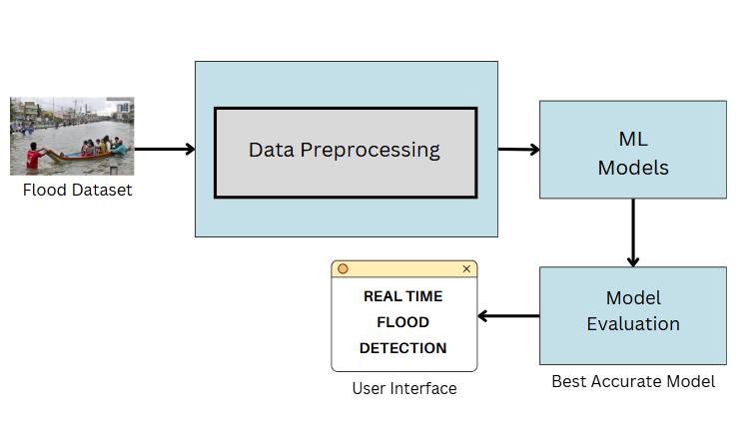
Figure 1: System Architecture
1.Data Collection & Preparation
The first step involves gathering relevant environmental and climatic data required to predict floods. This includes parameters such as annual rainfall, seasonal rainfall, cloud cover, humidity, water level, and other hydrological indicators. The dataset may be sourced from government portals, meteorological departments, remote sensing data, or Kaggle repositories. Once the dataset is collected, the data preparation process begins. This includes removing duplicate records, handling missing values, converting categorical variables into numerical forms, normalizing feature ranges, and transforming the data into a structured format suitable for model training. Proper data preparation ensures the quality and reliability of the predictions.
2. Exploratory Data Analysis (EDA)
EDA is performed to understand the underlying patterns, distributions, and relationships between the variables in the dataset.
- Univariate Analysis focuses on the statistical behavior of individual features, such as rainfall intensity or river water level.
- Multivariate Analysis examines interactions between variables, helping to identify which features contribute most to flood occurrences.
- Descriptive Analysis is used to compute summary statistics such as mean, median, standard deviation, and variance.
After the data is thoroughly analyzed, it is then split into training and testing datasets to evaluate model performance objectively.
3. Model Building
This phase involves developing and testing machine learning models capable of classifying and predicting flood conditions. The training phase uses the prepared training dataset to train the model using algorithms such as Decision Tree and Random Forest. During testing, the model is evaluated using the testing dataset to assess its ability to generalize to unseen data. Performance evaluation is performed using metrics like accuracy, precision, recall, and F1-score, ensuring that the model correctly identifies both flood and non-flood scenarios. Multiple models are tested, and the best-performing one is selected based on evaluation results.
4. Model Deployment
Once the best machine learning model is identified, it is saved using model serialization techniques such as Joblib or Pickle. The model is then integrated into a web framework (Flask) to create a user-friendly interface. Through this interface, users can input real-time environmental parameters and receive flood prediction results instantly. This deployment phase enables real-time accessibility and practical utilization of the flood prediction system in real-world scenarios.

Algorithm for Training Model/System
In this work, we apply a Decision Tree model during the Flood Prediction phase to analyze environmental and climatic parameters and determine whether a flood is likely to occur. The Decision Tree algorithm identifies patterns and relationships between input features and the target outcome (Flood / No Flood). It works by splitting the dataset into branches based on decision rules, ultimately forming a tree that predicts the result for new input values.
The proposed model follows the steps below (as shown in Figure 2):
- Input Data:
Environmental and hydrological data such as annual rainfall, seasonal rainfall, cloud cover, temperature, and water level values are provided as input to the model.
- Feature Selection:
The model identifies the most influential features that contribute to flood occurrence, such as sudden increase in rainfall or river discharge levels.
- Decision Nodes:
The dataset is split into smaller subsets based on threshold conditions (e.g., “Rainfall > 120 mm → Possible Flood”). Each node represents a decision rule.
- Leaf Nodes:
Once splitting results in groups that cannot be further divided, leaf nodes are generated. Each leaf node indicates a final prediction (e.g., Flood or No Flood).
- Prediction Output:
Based on the selected features and learned decision rules, the model classifies new input values and predicts the likelihood of a flood occurring.
During the training phase, the Decision Tree model learns by minimizing classification errors using impurity measures such as Gini Index or Entropy. Model performance is evaluated using metrics like accuracy, precision, recall, and F1-score to ensure reliable prediction. The optimized model is then integrated into the flood prediction system for real-time use. As new climate data becomes available, the model can be retrained to adapt to changing environmental conditions

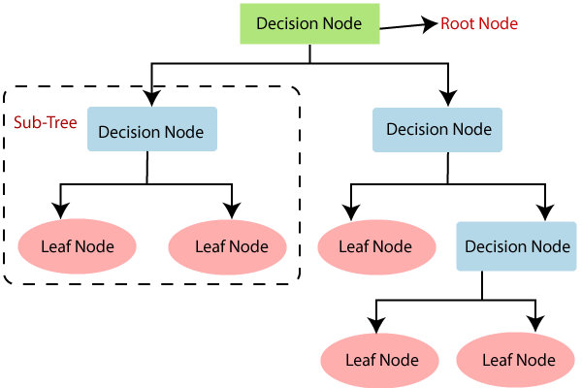

Figure 2: Flood Prediction using Decision Tree model

UML Diagrams
Unified Modelling Language (UML) is a standardized visual modeling language used in software engineering and system design. UML is a method for describing the system architecture in detail using the blueprint. UML represents a collection of best engineering practice that has proven successful in the modeling of large and complex systems. The UML is very important parts of developing object-oriented software and the software development process. It provides a way to represent the structure and interactions of a system.
- Purpose of UML
UML helps software developers, architects, and stakeholders communicate and understand complex systems. It serves as a common language for discussing system designs and requirements.
- Types of UML Diagrams
  - Class Diagram: Depicts the static structure of a system, including classes, attributes, methods, and their relationships.
  - Use Case Diagram: Illustrates interactions between actors (users or external systems) and the system.
  - Activity Diagram: Represents workflows or processes within the system.
  - Sequence Diagram: Shows interactions between objects over time.
  - State Machine Diagram: Models the behavior of an object or system in response to events.
  - Component Diagram: Displays the components and their dependencies in a system.
  - Deployment Diagram: Describes the physical deployment of software components on hardware nodes.

Common Elements in UML Diagrams
  - Classes: Represent objects or concepts in the system.
  - Associations: Show relationships between classes.
  - Attributes: Describe properties of classes.
  - Operations/Methods: Define behavior associated with classes.
  - Actors: Represent external entities interacting with the system in use case diagrams.

Benefits of Using UML
  - Clarity: UML diagrams provide a clear visual representation of system component

  - Consistency: UML enforces consistency in design and documentation.
  - Analysis and Design: UML aids in system analysis, design and implementation.

Use Case Diagram
Use case diagram represents the functionality of the system. Use case focus on the behavior of the system from external point of view. Actors are external entities that interact with the system.

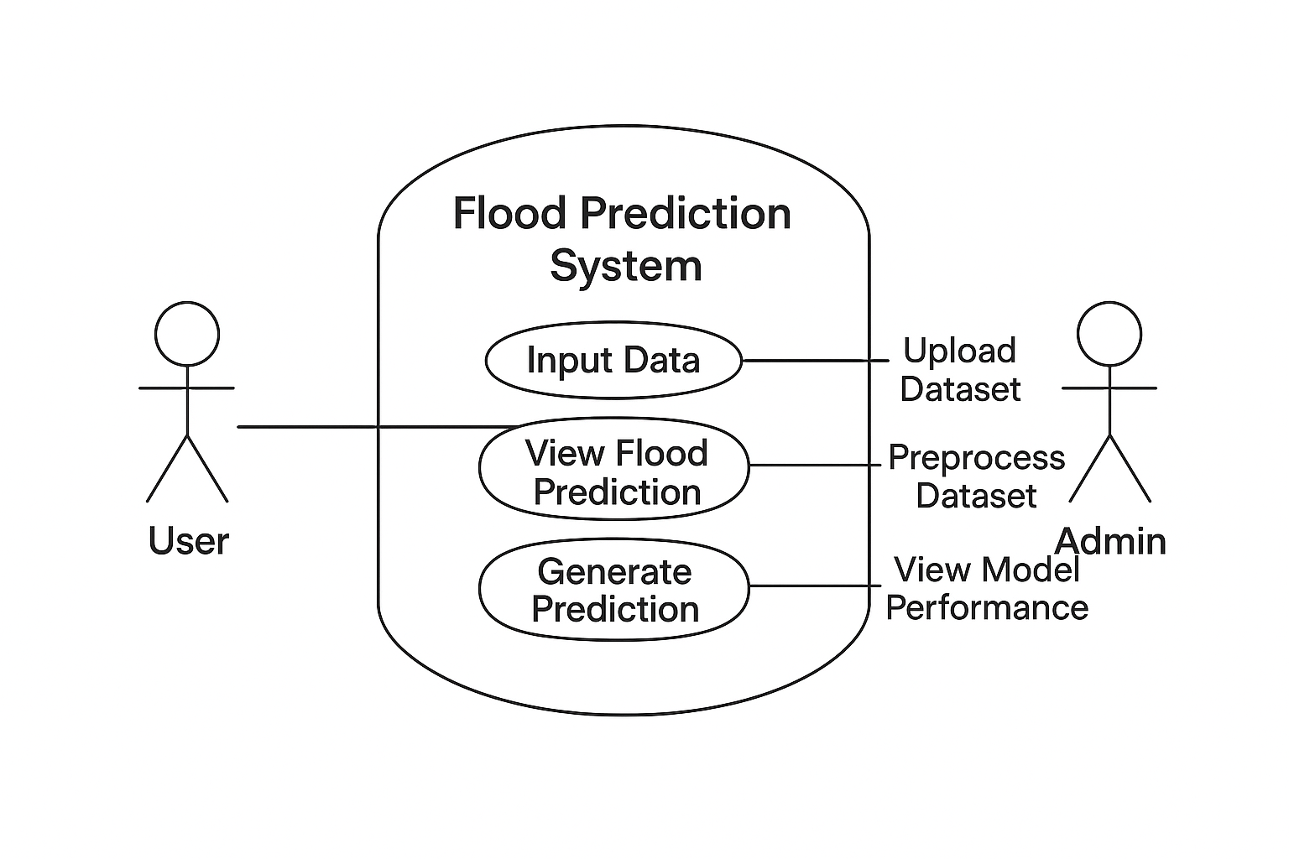
Figure 3: Use case Diagram

Purpose
  - The Use Case Diagram represents the interactions between the user and the flood prediction system, showing what functions the user can perform and how the system responds. It highlights the system’s functionality from the user’s perspective rather than focusing on internal operations. The primary actor in this system is the User, who interacts through a web-based interface. Optional actors can include Admin for model retraining or dataset updates.

Actors
  - System: The Flood Prediction System is the core software that processes input data and generates flood predictions. It uses a trained Decision Tree model to analyze environmental factors and determine whether a flood may occur. The system manages all operations such as data handling, prediction processing, and displaying results to users.
  - User: The User interacts with the system to check flood predictions. They enter required parameters like rainfall and cloud cover, submit them to the system, and view the prediction output. Their role is limited to input and output interaction; they do not modify the dataset or model.

Admin: The Admin manages the dataset and model. They upload new climate data, preprocess and clean it, retrain the model if needed, and monitor its performance to ensure the system remains accurate. The admin ensures the system works reliably for users.

Process Flow and Interactions
- Data Acquisition: The system first collects climate and rainfall data from reliable sources or uploaded datasets. This data forms the basis for predicting flood likelihood.
- • Data Preparation: The collected data is then preprocessed by cleaning missing values, scaling features, and selecting important parameters such as rainfall, cloud cover, and seasonal values. This ensures the data is ready for model training or prediction.
- • Model Application: The system uses a Decision Tree model to analyze the processed data. The model identifies patterns that indicate whether flood conditions are likely to occur.
- • User Interaction: The User interacts with the system by entering environmental values (e.g., rainfall amount, cloud cover). The system then uses these inputs to generate a real-time flood prediction.
- • Model Selection (Optional): If multiple models are tested, the system may evaluate performance and select the most accurate model for deployment. In this case, the Decision Tree is chosen for its accuracy and interpretability.
- • Prediction and Output: The system generates the flood prediction result, indicating whether a flood is likely or not. The output is displayed to the user in a clear and understandable format.

Activity Diagram
Activity diagrams are graphical representations of workflows of stepwise activities and actions with support for choice, iteration, and concurrency. In the Unified Modeling Language, activity diagrams can be used to describe the business and operational step-by-step workflows of components in a system. An activity diagram shows the overall flow of control.
Figure 4: Activity Diagram
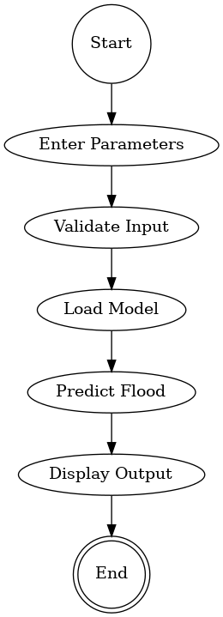

Purpose:
This activity diagram illustrates the process of predicting floods in a region using a machine learning model. It outlines the steps a user takes, the system’s data validation, model prediction, and subsequent actions based on the flood prediction outcome.

Process Flow:
Admin/User Log-in:
- The process begins with the Admin or User logging into the system. This ensures secure access and authentication before any flood prediction analysis.
Dataset Upload:
- The user uploads a dataset containing environmental and rainfall data. This dataset may include features such as annual rainfall, seasonal rainfall (Jan–Feb, Mar–May, Jun–Sep), cloud cover, river levels, and other relevant data for flood prediction.
Dataset Validation:
- The system validates the uploaded dataset for completeness, correct format, and integrity.
- If the dataset is invalid, an Error Message is displayed, prompting the user to correct the issues.
- If valid, the process continues.
Flood Prediction Page:
- Upon successful validation, the user is directed to the Flood Prediction Page.
- Here, the user can enter specific environmental parameters for real-time flood prediction.
Model Processing (Decision Tree):
- The entered parameters are processed by the trained Decision Tree or CNN model to predict the likelihood of a flood.
- The model analyses patterns in rainfall, cloud cover, and other features to determine flood risk.
Flood Prediction Outcome:
- High Flood Risk: The system displays an Alert, notifying the user of potential flood and possible preventive measures.
- Low Flood Risk: The system displays a Safe/No Flood Alert message, confirming low likelihood of flooding.
Process Completion:
- Regardless of the outcome, the process concludes at the final state, indicated by a filled circle in the activity diagram.

Class Diagram
A class diagram in UML (Unified Modelling Language) is a graphical representation of the structure and relationships among classes in a system. It depicts the static view of the system,
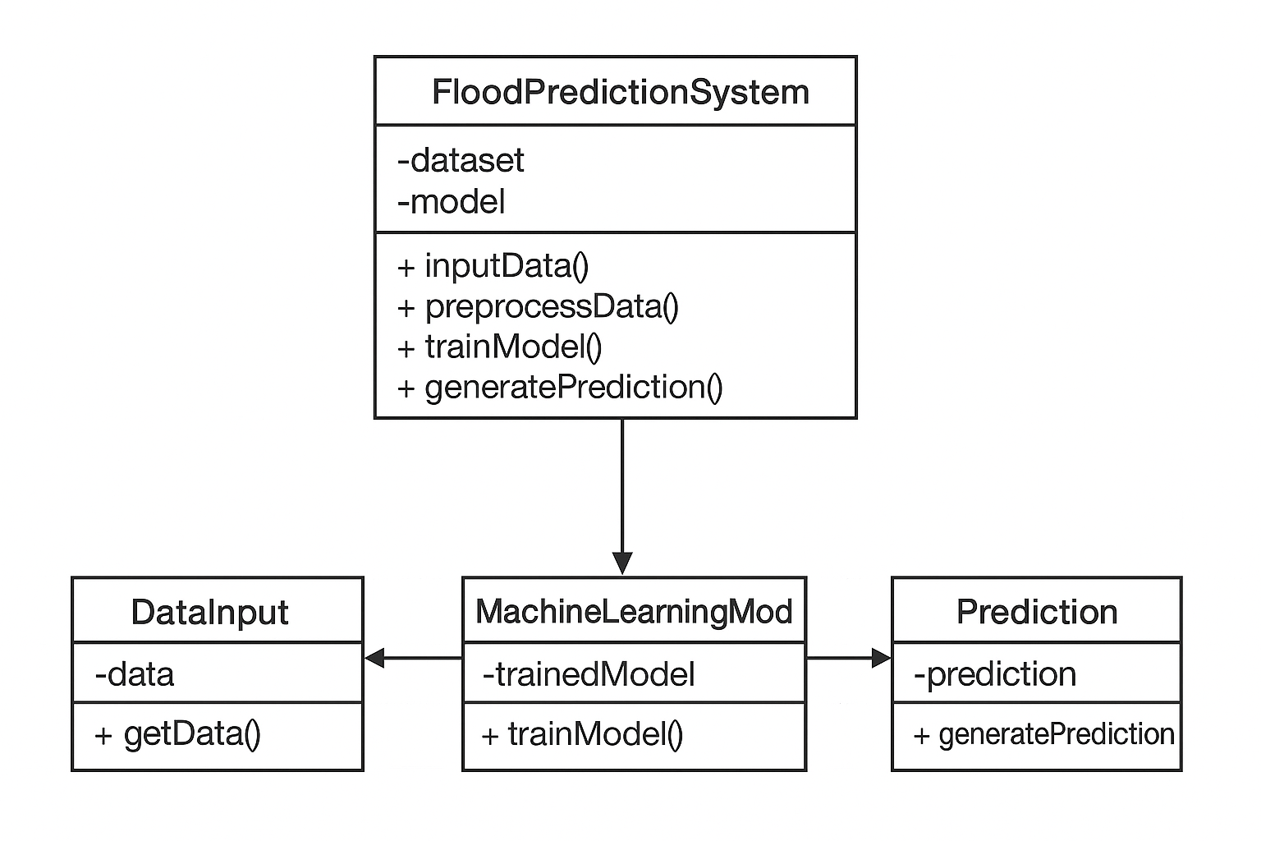

Figure 5: Class Diagram

Purpose

A class diagram represents the static structure of a system by showing its classes, their attributes, methods, and the relationships between them. For a flood prediction system using machine learning, the diagram shows how data flows and how different modules interact.
Classes and Their Explanation
- User
  - Attributes: userID, username, password, role
  - Methods: login (), logout (), submit Data ()
  - Explanation: Represents the end user or admin accessing the system. Handles authentication and submission of environmental parameters or datasets.
- Dataset
  - Attributes: dataset, datatype, data Features, upload Date
  - Methods: upload Dataset (), validate Dataset ()
  - Explanation: Represents the environmental or rainfall data uploaded to the system. Includes data validation functionality.
- DataPreprocessor
  - Attributes: scale type, missingValueMethod
  - Methods: clean Data (), normalize Data (), encodeFeatures ()
  - Explanation: Responsible for preprocessing raw data, handling missing values, scaling, and preparing it for model input.
- Flood Prediction Model
  - Attributes: model ID, model Type (e.g., Decision tree), accuracy
  - Methods: train Model (), predict Flood ()
  - Explanation: Represents the machine learning model that predicts flood occurrence based on input data.
- Prediction Result
  - Attributes: result ID, flood Risk Level, prediction Date
  - Methods: display Result (), save Result ()
  - Explanation: Stores the output of the model, including flood risk levels and prediction timestamps. Can be used for logging and reporting.
- Alert System
  - Attributes: alert ID, alert Type, message
  - Methods: send Alert (), notify User ()
  - Explanation: Generates alerts or notifications for high flood risk predictions, sending them to the user via the interface.

Relationships
- User → Dataset: One user can upload multiple datasets. (Association)
- Dataset → DataPreprocessor: Dataset is processed before prediction. (Association)
- DataPreprocessor → Flood Prediction Model: Preprocessed data is fed into the model. (Dependency)
- Flood Prediction Model → Prediction Result: Model produces a prediction result. (Association)
- Prediction Result → Alert System: High-risk predictions trigger alerts. (Association)

Object Diagram
An object diagram models the instances of classes in a class diagram. An object diagram contains objects and links connecting the related objects. Object diagrams allow us to model the static design view or static process view.
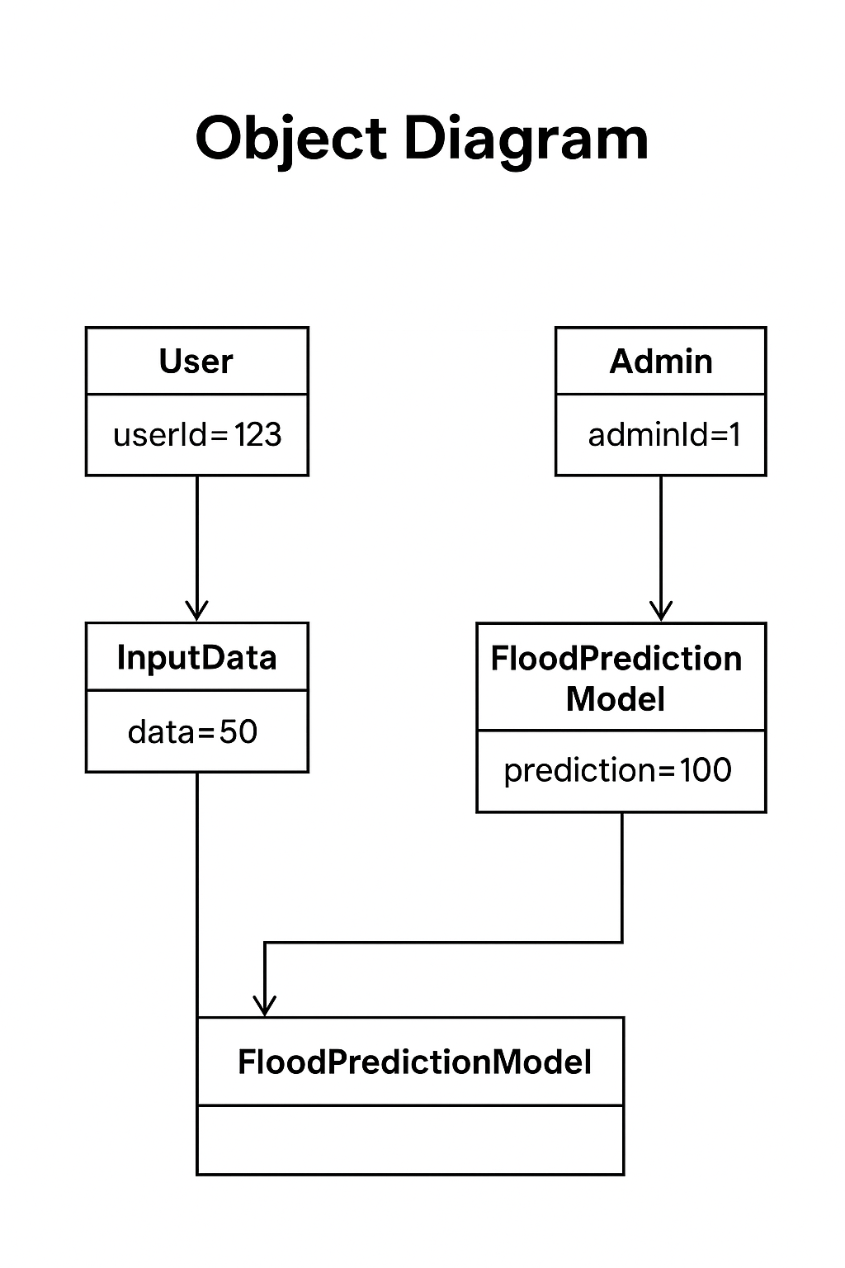

Figure 6: Object Diagram

Purpose
This Object UML Diagram illustrates the runtime relationships between specific instances of classes in the flood prediction system. It provides a snapshot of how data flows between users, administrators, and the prediction model, helping stakeholders understand the system’s operational structure.
.

Objects and Their Explanations
In the flood prediction system, several key objects interact to deliver accurate and user-driven predictions. The User object, identified by user Id = 123, represents an individual accessing the system to submit environmental data. This user provides input through the Input Data object, which holds the value data = 50, symbolizing real-world parameters such as rainfall or river levels. This data is crucial for the system’s predictive capabilities. The Flood Prediction Model object, with a prediction = 100, processes the input data to generate a forecast, indicating the likelihood or severity of flooding. This model is also linked to an Admin object (admin Id = 1), who oversees the system’s operation, ensuring the model is functioning correctly and possibly updating its parameters. Additionally, a second instance of the Flood Prediction Model appears in the diagram, suggesting a modular or layered architecture—perhaps representing a shared prediction engine or an abstracted version used by both the input and primary model components. Together, these objects illustrate a dynamic system where user input drives predictions, administrative oversight ensures reliability, and the model architecture supports scalability and refinement

Relationships
  - Initiates: The "Initiates" association between the User object and the Input Data object indicates that the user initiates the data submission process. This means the user provides environmental parameters such as rainfall, water level, or location details, which are essential for generating flood predictions.
  - Analyzed by: The "Analyzed by" association between the Input Data object and the Flood Prediction Model object indicates that the flood prediction model analyzes the submitted data. This model processes the input to assess flood risk and generate predictive outcomes based on historical patterns and real-time metrics

Sequence Diagram
A sequence diagram is a Unified Modelling Language (UML) diagram that illustrates the sequence of messages between objects in an interaction. A sequence diagram consists of a group of objects that are represented by lifelines, and the messages that they exchange over time during the interaction.

Purpose
The Sequence UML Diagram illustrates the step-by-step interaction between system components over time. It focuses on how objects communicate to fulfill the flood prediction request, showing the order of messages exchanged from input to output.
.

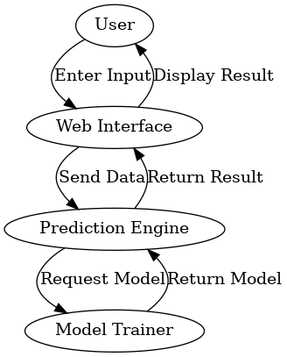

Figure 7: Sequence diagram

Explanation of the Diagram Contents
Key Participants
- User: Initiates the process by entering environmental data.
- Web Interface: Collects input and displays prediction results.
- Prediction Engine: Processes input and performs inference using the Decision Tree model.
- Model Trainer: Supplies the trained model to the Prediction Engine.
Interaction Flow
- User → Web Interface:
The user enters flood-related input data (e.g., rainfall, river level, humidity).
- Web Interface → Prediction Engine:
The Web Interface sends the collected data to the backend for analysis.
- Prediction Engine → Model Trainer:
The Prediction Engine requests the latest trained Decision Tree model.
- Model Trainer → Prediction Engine:
The Model Trainer returns the trained model for inference.
- Prediction Engine → Web Interface:
The Prediction Engine uses the model to generate a flood risk prediction and sends the result back.
- Web Interface → User:
The Web Interface displays the prediction result to the user (e.g., “High Risk”, “Low Risk”).
Sequence Logic Summary
- The diagram emphasizes temporal ordering: each message is triggered by the previous one.
- It shows synchronous communication, where each component waits for a response before proceeding.
- The Decision Tree model is treated as a reusable asset, requested dynamically by the Prediction Engine.
- The system returns to an idle state after displaying the result, ready for the next user input.

State Diagram
A state diagram is a UML behavioral diagram that shows the different states of a system and how it transitions between them. In a flood prediction system, it represents states like Normal, Alert, Warning, and Flood, and the events (e.g., rainfall thresholds) that trigger transitions between these states.
.

States:

States in Flood Prediction System

Definition: A state represents a condition of the flood prediction system or the monitored area at a specific point in time.

Examples of states:

Normal Condition: No flood risk detected; rainfall is within safe limits.

Alert Condition: Heavy rainfall observed; flood risk is rising.

Warning Condition: Critical rainfall or water levels; immediate action may be needed.

Flood Condition: Flood detected; emergency measures activated.

Activities in a state:

In the Normal Condition, the system monitors rainfall data continuously.

In the Alert Condition, the system sends notifications to users.

In the Warning Condition, predictive models calculate the potential flood impact.

In the Flood Condition, the system alerts authorities and triggers emergency warnings.

Representation: States are shown as rounded rectangles containing the state name.

Transitions in Flood Prediction System

Definition: A transition represents the change from one flood risk state to another.

Examples:

From Normal Condition → Alert Condition when rainfall exceeds a threshold.

From Alert Condition → Warning Condition when water levels rise further.

From Warning Condition → Flood Condition when flood is imminent.

Triggers: Transitions occur due to events like rainfall measurements, river water levels, or sensor alerts.

Representation: Arrows connecting states, optionally labeled with the triggering event and any conditions (e.g., rainfall > 100mm).

Events in Flood Prediction System

Definition: An event is any occurrence that can trigger a state transition in the system.

Examples:

Heavy rainfall detected.

River water level crosses danger mark.

Sudden cloud cover or storm signal.

Passage of time (e.g., hourly updates).

Initial and Final States

Initial State:

Represents the starting point of monitoring, usually Normal Condition.

Depicted as a solid circle.

Final State:

Represents the end of the prediction process, e.g., Flood Condition resolved or Monitoring stopped.

Depicted as a double circle.
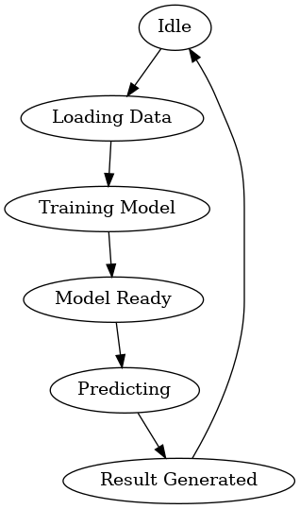

Figure 8: State Diagram

Purpose of the State Diagram
The primary purpose of this state diagram is to visualize the different states and transitions of the flood prediction system. It shows the sequence of actions and decisions from the moment environmental data is received to the final flood alert outcome.

Initial State (Solid Circle):
  - Starting point of the system monitoring. The system begins by collecting rainfall and environmental data.
Data Collection (Rounded Rectangle):
  - The system gathers rainfall, river water levels, cloud cover, and other environmental parameters.
Data Received (Transition):
  - Event that triggers the transition from "Initial State" to "Data Analysis" once sufficient data is collected.
Data Analysis (Rounded Rectangle):
  - The system analyzes the collected data using the trained flood prediction model.
Threshold Check (Diamond / Decision Node):
  - Decision point where the system evaluates whether rainfall or water levels exceed safety thresholds.
If Safe (Transition → Normal Condition):
  - If conditions are within safe limits, the system transitions to the "Normal Condition" state.
Normal Condition (Rounded Rectangle):
  - No flood risk detected; the system continues monitoring.
If Risk Detected (Transition → Alert Condition):
  - If rainfall or water levels are rising, the system transitions to the "Alert Condition" state.
Alert Condition (Rounded Rectangle):
  - System issues preliminary warnings to users or authorities.
If Critical (Transition → Warning Condition):
  - If data shows a high probability of flood, the system transitions to the "Warning Condition" state.
Warning Condition (Rounded Rectangle):
  - System calculates potential impact and sends detailed alerts to authorities and users.
If Flood Imminent (Transition → Flood Condition):
  - If flooding is confirmed or highly likely, the system transitions to the "Flood Condition" state.
User / Authority Alerted (Transition):
  - Event indicating that users or authorities have received alerts, leading toward the final monitoring state.
Final State (Double Circle):
  - End of the current monitoring cycle or flood response execution.

Components Diagram
A component diagram is a type of diagram within the Unified Modeling Language (UML) that visually represents the physical components of a software system and their relationships. It focuses on the structural aspects of a system, showing how the different parts are organized and interconnected.

Key Characteristics of Component Diagrams:
1.Physical Components:
- Represent the main system modules:
  - Data Collection – gathers rainfall, river levels, etc.
  - Data Processing – cleans and prepares data.
  - Prediction Model – forecasts flood risk.
  - Notification – sends alerts to users/authorities.
  - User Interface – displays predictions and alerts.
2. Interfaces:
- Provided: Services offered by a component (e.g., processed data from Data Processing to Prediction Model).
- Required: Services a component needs (e.g., Prediction Model needs data from Data Processing).
3. Relationships / Dependencies:
- Components depend on each other for data flow and functionality:
  - Prediction Model → Data Processing
  - Notification → Prediction Model
  - User Interface → All modules
4. Valid Transaction / Final State:
- Represents successful completion of a prediction cycle: data processed, forecast generated, and alerts sent.
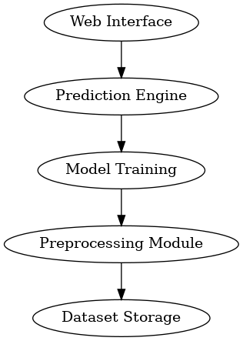

Figure 9: Components diagram

Purpose
The component diagram shows the main system modules, their interactions, and dependencies. It helps visualize how data flows, how components interact, and ensures smooth integration.

Components
- Environmental Data – Stores rainfall, river levels, and other sensor data.
- Prediction System – Processes data and predicts flood risk using ML models.
- User Interface – Lets users view predictions and receive alerts.

Relationships
- Dependencies:
  - Prediction System depends on Environmental Data.
  - User Interface depends on Prediction System for results and alerts.

Interpretation
- Environmental Data is the central source.
- Prediction System analyzes data to forecast floods.
- Users interact through the interface to get alerts and updates.

Deployment Diagram
A deployment diagram shows how software components are physically deployed on hardware nodes and how they communicate. It helps visualize the system architecture, ensuring efficient data flow and system performance.

Key Elements
- Nodes:
  - Server / Cloud Instance: Runs the flood prediction system.
  - Workstation / User Device: Accesses the system via web or mobile interface.
  - Database Server: Stores historical rainfall, river levels, and sensor data.
- Artifacts (Software Components):
  - Data Processing Module: Cleans and prepares environmental data.
  - Decision Tree Prediction Module: Predicts flood risk.
  - Notification Module: Sends alerts to users or authorities.
  - User Interface Module: Displays forecasts and alerts.
- Communication Paths:
  - Server ↔ Database: Fetch and store data.
  - Server ↔ User Device: Display predictions and alerts.
  - Modules ↔ Decision Tree Module: Provide processed data and receive predictions.
- Deployment Specifications:
  - Secured via HTTPS and authentication.
  - Cloud storage can be used for backup datasets.
  - Real-time data updates for accurate flood forecasting.

Interpretation
- Historical and real-time environmental data is collected and stored.
- Decision Tree model analyzes the data to forecast flood risk.
- Alerts and predictions are delivered to users via the interface, ensuring timely flood warnings.

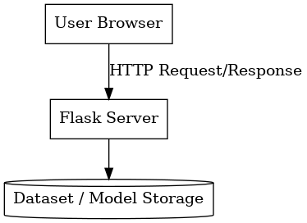
Figure 10: Deployment Diagram

- Purpose: The diagram illustrates the flow of data and key processing components in the Flood Prediction System. It shows how environmental data is collected, processed, analyzed, and used to generate flood alerts.

- Explanation of the Diagram Contents
  - Components
- Flood Prediction System (3D Box): Overall system containing all processing modules.
- Environmental Data (3D Cylinder with Sensor Icon): Input data including rainfall, river levels, and sensor readings.
- Data Preprocessing (Rounded Rectangle): Cleans and formats raw environmental data for analysis.
- Decision Tree Model (Rounded Rectangle): Core processing component that predicts flood risk based on preprocessed data.
- User / Authority (3D Box): Interacts with the system to view predictions and receive alerts.
- Flood Alert Process (Rounded Rectangle): Generates alerts and recommendations based on model predictions.
.

Data Flow (Arrows)
- Environmental Data → Data Preprocessing: Raw data is cleaned and prepared.
- Data Preprocessing → Decision Tree Model: Preprocessed data is analyzed.
- User → Decision Tree Model: User may input parameters or feedback.
- Decision Tree Model → Flood Alert Process: Predictions are used to trigger alerts.
- Flood Alert Process → Flood Prediction System: Results are integrated into the system for reporting.

Interpretation
- Shows sequential flow from data collection → preprocessing → prediction → alert.
- Highlights Decision Tree model as the core component.
- Illustrates user interaction for receiving alerts.
- Ensures timely flood warnings and accurate predictions for risk mitigation.

Modules
The Flood Prediction System is designed with a modular architecture to ensure efficiency, accuracy, and user-friendliness. Each module performs a distinct function, from collecting and processing environmental data to predicting flood risk and generating timely alerts. As shown in the system architecture, these modules work together to process data from multiple sources, including rainfall measurements, river water levels, cloud cover, and historical weather data, passing it through the Data Preprocessing stage and the Decision Tree Prediction Model, and finally culminating in the Flood Alert Process. This structured approach ensures that raw environmental data is transformed into meaningful, actionable predictions.
The Data Collection module is responsible for gathering real-time and historical environmental data from sensors, weather stations, and other external sources. The Data Preprocessing module cleans, normalizes, and formats the collected data, making it suitable for analysis by the machine learning model. At the heart of the system, the Decision Tree Prediction Model analyzes patterns in the preprocessed data to classify flood risk levels, identifying areas or regions that are at potential risk. Based on the model’s output, the Flood Alert Process generates alerts and recommendations, which are communicated to users or local authorities through the User Interface module. Users can view predictions, flood warnings, and historical data, enabling informed decision-making and timely response.
This modular design not only improves efficiency and prediction accuracy but also allows for scalability and flexibility. New data sources, predictive models, or additional alert mechanisms can be integrated without disrupting the existing system. The architecture also helps identify potential bottlenecks in data processing or alert generation, allowing for optimization to ensure real-time flood forecasting with minimal latency. By providing a clear structure for developers and stakeholders, this design facilitates efficient implementation, testing, and continuous improvement, enabling proactive flood management. Overall, the system provides a robust, reliable, and user-friendly solution for monitoring, predicting, and responding to flood risks, helping mitigate damage and enhance community safety.

Home Page

Purpose: The Home Page serves as the central hub for users in the Flood Prediction System. It provides an overview of current flood risk levels, recent predictions, and alerts, and allows users to navigate to other modules such as Data Input, Prediction Reports, and Alert Settings.

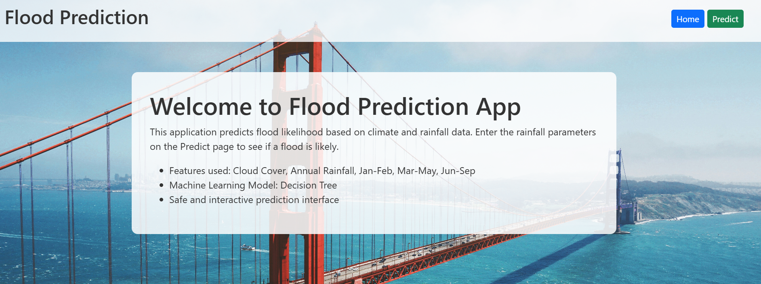

Figure 11: Home Page
Purpose:

This page acts as the main interface for the Flood Prediction system, designed for user-friendliness and easy navigation. It may involve dynamic data retrieval from the database to display real-time rainfall and climate information. The interface integrates machine learning predictions with a clean and interactive layout to help users understand flood risks quickly.

Functionality:

Includes buttons or links (like Home and Predict) that allow users to move easily between pages — for example, viewing prediction results, entering new rainfall data, or checking analysis reports

Prediction Page

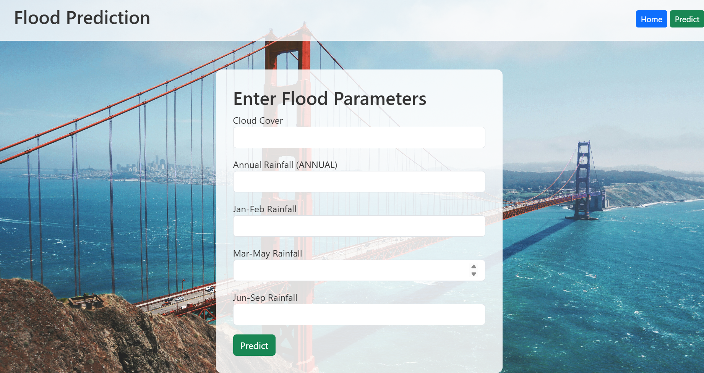

Figure 12: prediction Page
Purpose
The Prediction Page serves as the core functional area of the Flood Prediction App. It allows users to input real-time rainfall and climate parameters for analysis. The interface is designed for simplicity and accuracy, ensuring users can easily enter data like rainfall or cloud cover. The page may interact with a machine learning model hosted on a backend server to generate predictions dynamically and display the results instantly.

Functionality:

a. Input Parameters:
Users can enter various climate factors such as Cloud Cover, Annual Rainfall, and Seasonal Rainfall (Jan–Feb, Mar–May, Jun–Sep). These serve as input features for the machine learning model.

b. Prediction Button:
The “Predict” button triggers the model to analyze the entered data and estimate whether flood conditions are likely or not.

Result Page
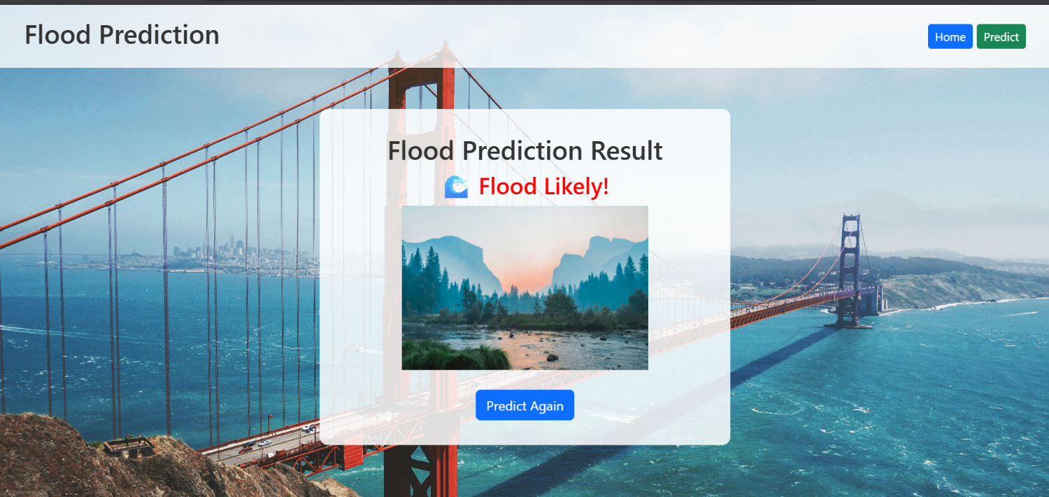
Figure 13: Result Page
Purpose
The Result Page displays the output of the flood prediction model after analyzing the user’s input data. It is designed to provide clear and immediate feedback to the user. The page dynamically retrieves the prediction results from the machine learning model (Decision Tree) and visually represents whether a flood is likely or not likely based on the rainfall and climate parameters entered.

Functionality:

Prediction Output:
Displays the final prediction result such as:

“Flood Likely!” – indicates a high chance of flood occurrence based on current parameters.

“Flood Not Likely!” – indicates a low or no risk of flood based on the entered data.

CHAPTER 5: IMPLEMENTATION

Algorithms
Within our Flood Prediction System, the core intelligence lies in the "Machine Learning Models (Decision Tree, Random Forest, KNN, XGBoost)" module, as shown in the system architecture. This module represents the analytical engine of the system, where various supervised machine learning algorithms are applied to environmental and rainfall data. After the "Data Preprocessing" of the Climate and Rainfall Dataset (CSV), the system utilizes these algorithms to learn patterns related to flood occurrence. Models such as Decision Tree help in clear rule-based classification, Random Forest provides improved accuracy and robustness, KNN supports instance-based prediction for similar climatic conditions, and XGBoost ensures high-performance gradient boosting for better prediction accuracy. The output generated by these models directly supports the "Flood Prediction Process", allowing us to estimate the likelihood of flood occurrences and provide early warnings for safety and preparedness.

Decision Tree
- Definition: A Decision Tree is a supervised machine learning algorithm that uses a tree-like structure of decisions and outcomes to classify data based on feature values.
- Explanation for Flood Prediction:
a. In flood prediction, the branches of the tree represent decisions based on environmental features such as rainfall amount, river water level, humidity, cloud cover, etc.
b. For example, if rainfall > threshold, the decision moves to one branch; otherwise, it moves to another.
c. The leaf nodes of the tree represent the final classification outcomes: Flood (1) or No Flood (0).
d. This model is easy to visualize and interpret, making it useful for developers, researchers, and disaster management teams to understand how the prediction is being made and ensure effective implementation in the system.

Random Forest
- Definition: Random forest is an ensemble learning method that combines multiple decision trees to improve prediction accuracy and reduce overfitting.

Explanation for Flood Prediction:
- It builds many decision trees; each trained on a random subset of the data and features.
- The final prediction is based on the majority vote of all the trees.
- This reduces the risk of relying on a single tree's potentially biased decision.\

XG Boost (Extreme Gradient Boosting)
- Definition: XG Boost is a powerful ensemble machine learning algorithm based on gradient boosting, which builds a series of decision trees where each new tree improves the errors of the previous ones. It is known for its high accuracy, speed, and efficiency in classification tasks.
- Explanation for Flood Prediction:
a. In flood prediction, XG Boost analyzes multiple environmental features such as rainfall, cloud cover, river water level, humidity, and seasonal rainfall patterns to learn complex patterns that lead to flooding.
b. It builds multiple decision trees, where each tree focuses on improving the prediction accuracy by minimizing errors from the previous trees.
c. XG Boost is effective at capturing non-linear relationships in climate data, making it highly suitable for precise flood prediction.

K-Nearest Neighbors (KNN)
- Definition: KNN is a non-parametric algorithm that classifies a data point based on the majority class of its k-nearest neighbors.

Explanation Flood Prediction:
For a new environmental input (such as rainfall, river level, humidity, etc.), the KNN algorithm finds the k most similar historical records in the dataset. If most of those similar records indicate flood occurrence, the model classifies the current condition as Flood (1).
If the system predicts a flood, it can trigger an early warning alert, notifying local authorities and communities to take precautionary measures.

Sample Code

Following are the commands, we need install one by one inside the terminal before running the code:
flask==2.3.3
NumPy==1.26.4
pandas==1.5.3
matplotlib==3.10.0
seaborn==0.12.2
scikit-learn==1.3.0

Main Code:
BUILDING THE TRAINED MODEL
import pandas as pd
import numpy as np
import matplotlib.pyplot as plt
import seaborn as sns
import joblib
from sklearn.model_selection import train_test_split
from sklearn.preprocessing import StandardScaler
from sklearn.tree import DecisionTreeClassifier
from sklearn.ensemble import RandomForestClassifier
from sklearn.neighbors import KNeighborsClassifier
from xgboost import XGBClassifier
from sklearn.metrics import accuracy_score, confusion_matrix, classification_report

df = pd.read_excel("flood dataset.xlsx")
print("✅ Dataset Loaded Successfully")
print("\n----- First Five Rows -----")
print(df.head())

print("\n----- Dataset Info -----")
print(df.info())

print("\n----- Statistical Summary -----")
print(df.describe())
# Distribution plots for numerical features
num_cols = ['Temp', 'Humidity', 'Cloud Cover', 'ANNUAL', 'Jan-Feb', 'Mar-May', 'Jun-Sep', 'Oct-Dec', 'avgjune', 'sub']

for col in num_cols:
plt.figure(figsize=(6,4))
sns.histplot(df[col], kde=True, color='teal')
plt.title(f'Distribution Plot of {col}')
plt.show()

# Boxplots to check outliers
for col in num_cols:
plt.figure(figsize=(6,4))
sns.boxplot(x=df[col], color='skyblue')
plt.title(f'Boxplot of {col}')
plt.show()

print("\nMissing values:\n", df.isnull().sum())
for col in num_cols:
Q1 = df[col].quantile(0.25)
Q3 = df[col].quantile(0.75)
IQR = Q3 - Q1
lower_limit = Q1 - 1.5 * IQR
upper_limit = Q3 + 1.5 * IQR
df[col] = np.where(df[col] < lower_limit, lower_limit,
np.where(df[col] > upper_limit, upper_limit, df[col]))

print("\n✅ Outliers handled using capping method")

plt.figure(figsize=(10,8))
sns.heatmap(df.corr(), annot=True, cmap='coolwarm')
plt.title("Correlation Heatmap")
plt.show()

# Selecting only specific columns for correlation
selected_features = ['Cloud Cover', 'ANNUAL', 'Jan-Feb', 'Mar-May', 'Jun-Sep']

plt.figure(figsize=(8,6))
sns.heatmap(df[selected_features].corr(), annot=True, cmap='coolwarm', linewidths=0.5)
plt.title("Correlation Heatmap of Rainfall & Cloud Cover Features")
plt.show()
df = df[['Cloud Cover', 'ANNUAL', 'Jan-Feb', 'Mar-May', 'Jun-Sep','flood']]
df
# Assuming all columns are numeric; if not:
df = pd.get_dummies(df, drop_first=True)
print("\n✅ Handled categorical variables (if present)")

X = df.drop('flood', axis=1)
y = df['flood']

X_train, X_test, y_train, y_test = train_test_split(X, y, test_size=0.25, random_state=42)
print("\n✅ Data split into Train and Test sets")

scaler = StandardScaler()
X_train_scaled = scaler.fit_transform(X_train)
X_test_scaled = scaler.transform(X_test)

# Save the scaler
joblib.dump(scaler, 'standard_scaler.pkl')
print("✅ StandardScaler saved as 'standard_scaler.pkl'")

models = {

"Decision Tree": DecisionTreeClassifier(random_state=42),

"Random Forest": RandomForestClassifier(random_state=42),

"KNN": KNeighborsClassifier(),

"XGBoost": XGBClassifier(use_label_encoder=False, eval_metric='logloss', random_state=42)

}
model_results = {}

for name, model in models.items():

model.fit(X_train_scaled, y_train)

y_pred = model.predict(X_test_scaled)

acc = accuracy_score(y_test, y_pred)

model_results[name] = acc

print(f"\n{name} Accuracy: {acc:.4f}")

print(confusion_matrix(y_test, y_pred))

print(classification_report(y_test, y_pred))
result_df = pd.DataFrame(list(model_results.items()), columns=['Model', 'Accuracy'])

plt.figure(figsize=(7,4))

sns.barplot(x='Model', y='Accuracy', data=result_df, palette='viridis')

plt.title('Model Comparison')

plt.show()

best_model_name = max(model_results, key=model_results.get)

best_model = models[best_model_name]

print(f"\n🏆 Best Model: {best_model_name} with Accuracy: {model_results[best_model_name]:.4f}")
# Save the best model
joblib.dump(best_model, f"{best_model_name.replace(' ', '_').lower()}_model.pkl")
print(f"✅ Saved Best Model as '{best_model_name.replace(' ', '_').lower()}_model.pkl'")
import joblib
import pandas as pd

# Load the saved model and scaler
model = joblib.load('decision_tree_model.pkl')
scaler = joblib.load('standard_scaler.pkl')

# 🔹 New sample data (must include only the trained input features)
new_data = pd.DataFrame({
'Cloud Cover': [60],
'ANNUAL': [900],
'Jan-Feb': [150],
'Mar-May': [200],
'Jun-Sep': [450]
})

# 🔹 Apply the same scaler used during training
new_data_scaled = scaler.transform(new_data)

# 🔹 Make prediction
prediction = model.predict(new_data_scaled)

# 🔹 Display result
print("🌊 Flood Prediction:", "Flood Likely" if prediction[0] == 1 else "No Flood")

Compare the model

Comparing the performance of different models is essential to identify the best approach for flood prediction. In this project, four models Decision Tree, Random Forest, K-Nearest Neighbors (KNN), and XG Boost were trained and evaluated using metrics such as accuracy, precision, recall, F1-score, and ROC-AUC. The Decision Tree model provided an interpretable and straightforward solution, capturing clear decision rules based on features like Cloud Cover, ANNUAL rainfall, and seasonal rainfall periods. It performed reasonably well but tended to overfit the training data, especially for extreme rainfall events, resulting in lower generalization on the test set compared to ensemble methods. The Random Forest model improved upon the Decision Tree by combining multiple trees through bagging, which reduced overfitting and increased predictive stability. By considering different random subsets of data and features for each tree, Random Forest achieved higher accuracy and F1-score, particularly in detecting rare flood events. Additionally, feature importance analysis from Random Forest revealed which environmental variables had the most impact on flood predictions, providing actionable insights for decision-makers. Overall, Random Forest struck a balance between accuracy, robustness, and interpretability, making it a strong candidate for deployment. KNN and XG Boost offered complementary strengths. KNN, being a non-parametric and instance-based learner, performed well in capturing local patterns in the data but was computationally intensive for larger datasets and sensitive to feature scaling. XG Boost, on the other hand, delivered the highest predictive performance by sequentially minimizing errors through gradient boosting and incorporating regularization techniques. It excelled in handling complex nonlinear relationships between rainfall, cloud cover, and flood occurrences, achieving superior ROC-AUC and F1-scores. While XG Boost required careful hyperparameter tuning and was less interpretable than Random Forest, its predictive power made it the best choice for high-stakes flood prediction scenarios where accuracy is paramount.

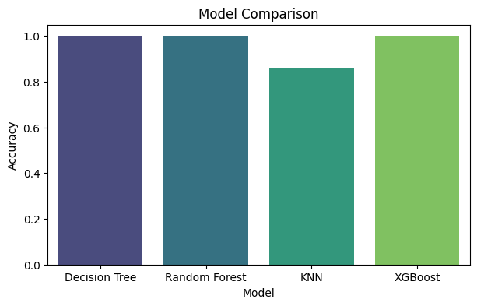
Fig.14 Model Comparison
Save the best model

After evaluating all the trained models Decision Tree, Random Forest, KNN, and XG Boost on multiple performance metrics, it is essential to save the best-performing model for future use. Saving the model allows it to be reused without retraining, which is especially valuable in real-world applications like flood prediction, where timely forecasts are critical. In this project, the Decision Tree model was selected as the best model based on its combination of high accuracy, F1-score, and interpretability. Once the model was finalized, it was serialized and saved using Python libraries such as joblib or pickle, which provide efficient ways to store machine learning models along with their parameters. The process of saving a model involves serializing the trained object into a file that can be easily loaded later for prediction. This ensures that all learned patterns, splits, and parameters in the decision tree are preserved. In Python, the joblib. Dump () function was used to save the model as a .pkl file.

CHAPTER 6: TESTING
6.1. Model Testing
Model testing is a critical phase in the machine learning workflow, as it evaluates how well a trained model generalizes to unseen data. In the context of flood prediction, after training models like Decision Tree, Random Forest, KNN, and XG Boost on features such as Cloud Cover, ANNUAL rainfall, and seasonal rainfall periods, testing ensures that the model can accurately predict flood occurrences in new environmental conditions. Proper testing provides a realistic measure of the model’s reliability and effectiveness in real-world scenarios. The first step in testing is to use the test set, which was kept separate during the data splitting phase. The test set contains data points that the model has not seen during training, serving as an independent evaluation benchmark. This separation prevents data leakage and ensures that performance metrics reflect the model’s true generalization ability rather than memorization of training data. For flood prediction, this allows the system to be evaluated on different combinations of rainfall and cloud cover patterns that were not part of the training process.
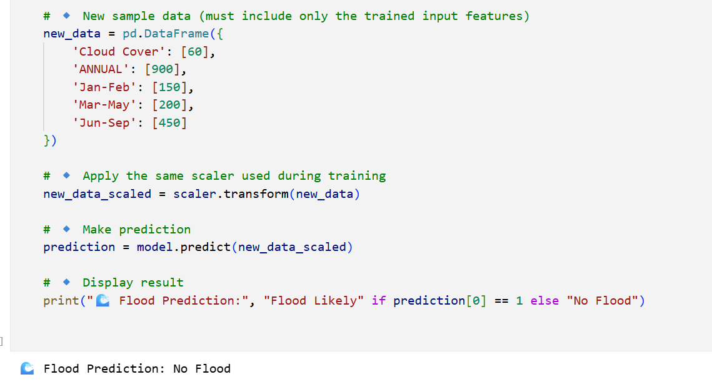

Fig 15 Testing Model with Sample Examples
Once predictions are generated on the test set, performance is assessed using classification metrics such as accuracy, precision, recall, and F1-score. Accuracy measures the overall proportion of correctly predicted flood and non-flood instances. Precision evaluates how many predicted floods were actual floods, while recall measures how many actual floods were correctly identified. The F1-score balances precision and recall, providing a single metric that accounts for both false positives and false negatives. These metrics collectively provide a comprehensive understanding of model performance. A confusion matrix is also employed to visualize prediction outcomes. It displays the number of true positives (flood correctly predicted), true negatives (no flood correctly predicted), false positives (non-flood predicted as flood), and false negatives (flood predicted as non-flood). Analyzing the confusion matrix for flood prediction helps identify specific weaknesses in the model, such as missing rare flood events or incorrectly flagging non-flood instances, enabling further refinement or retraining if necessary
Testing also involves ROC curves and AUC (Area Under the Curve) for binary classification models. The ROC curve plots the true positive rate against the false positive rate at various threshold settings. The AUC value quantifies the overall ability of the model to discriminate between flood and non-flood instances. A higher AUC indicates that the model reliably distinguishes between classes, which is particularly important in flood prediction, where accurately identifying high-risk situations can prevent damage and save lives. During testing, it is crucial to assess how each model handles imbalanced data, as flood events may be rarer than non-flood occurrences. Metrics such as precision, recall, and F1-score are especially valuable in these cases because accuracy alone can be misleading. For example, a model predicting “no flood” for all instances may achieve high accuracy but fail to identify critical flood events. Proper evaluation ensures that the model is effective for practical applications.
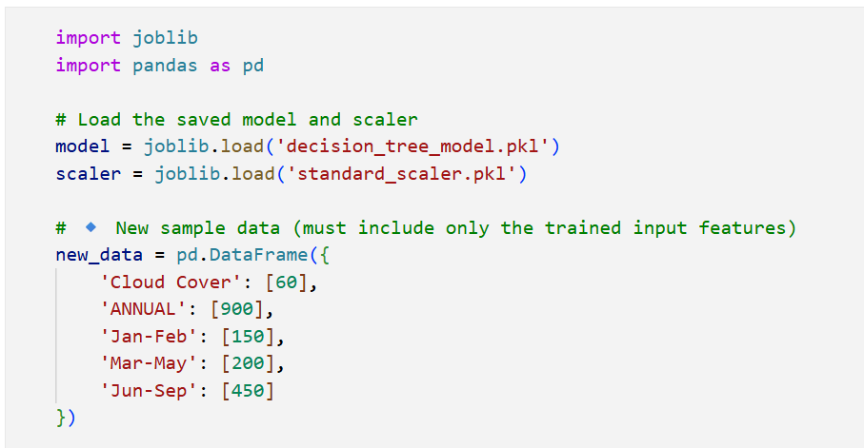

Fig 16 Making Predictions on Testing Samples
Visualizations such as bar plots or heatmaps of predicted vs actual values are helpful for qualitative evaluation. For flood prediction, comparing predicted flood probabilities to actual flood occurrences across different regions or time periods can reveal patterns, biases, or anomalies in the model’s performance. These visual insights supplement numerical metrics, providing a holistic view of model effectiveness. Testing also involves cross-validation on the training set to supplement test set evaluation. While the test set provides an unbiased estimate, cross-validation allows the model to be assessed across multiple folds of the data, reducing the risk of variance in evaluation. This step helps confirm that the model’s performance on the test set is representative of its expected performance in broader deployment scenarios, ensuring reliability for flood prediction applications. Error analysis is another important part of testing. By examining instances where the model failed—either false positives or false negatives insights can be gained into potential feature engineering improvements, outlier handling, or additional data requirements. For flood prediction, analyzing misclassified events may reveal patterns such as extreme rainfall or unusual seasonal behavior that the model struggled to capture, guiding future enhancements.

6.2. Performance Testing

Testing model with multiple evaluation metrics
Testing the model with multiple evaluation metrics is one of the most crucial steps in machine learning, as it provides a comprehensive understanding of how well a model performs on unseen data. For flood prediction, relying solely on a single metric like accuracy can be misleading, especially when the dataset is imbalanced, with fewer flood events compared to non-flood instances. Evaluating the model using multiple metrics ensures that both positive and negative predictions are accurately assessed, giving a holistic view of the model’s effectiveness. One of the fundamental metrics is Accuracy, which measures the proportion of correctly classified instances among the total number of predictions. The formula for accuracy is:
$$\text{Accuracy}=\frac{TP+TN}{TP+TN+FP+FN}$$
Here, $TP$represents true positives (flood correctly predicted), $TN$is true negatives (non-flood correctly predicted), $FP$is false positives (non-flood predicted as flood), and $FN$is false negatives (flood predicted as non-flood). While accuracy provides a quick overview, it may be misleading in imbalanced datasets. To address this, Precision is used, which evaluates the proportion of positive predictions that are correct. In flood prediction, precision indicates how many of the predicted floods were actual floods. The formula is:
$$\text{Precision}=\frac{TP}{TP+FP}$$
High precision ensures that the model minimizes false alarms, which is important for preventing unnecessary panic in flood warning systems. Recall (also called Sensitivity or True Positive Rate) measures the proportion of actual positive instances correctly identified by the model. For flood prediction, recall is critical because failing to detect a real flood (false negative) could have severe consequences. The recall formula is:

$$\text{Recall}=\frac{TP}{TP+FN}$$
A high recall ensures that most flood events are captured, even if it leads to some false positives. To balance precision and recall, the F1-Score is computed, which is the harmonic mean of precision and recall:
$$F1=2⋅\frac{\text{Precision}⋅\text{Recall}}{\text{Precision}+\text{Recall}}$$
The F1-score provides a single metric that considers both false positives and false negatives, making it particularly suitable for evaluating models on flood datasets where both types of errors are critical.
Another important evaluation tool is the Confusion Matrix, which is a tabular representation of predictions versus actual outcomes. The matrix includes four values: TP, TN, FP, and FN. It allows visual assessment of where the model is making errors, helping identify whether the model struggles more with false positives or false negatives in flood prediction scenarios. ROC (Receiver Operating Characteristic) Curve and AUC (Area Under the Curve) are widely used to evaluate model discrimination ability. The ROC curve plots the true positive rate ($TPR$) against the false positive rate ($FPR$) at various threshold settings. Formulas for $TPR$and $FPR$are:
$$TPR=\frac{TP}{TP+FN},FPR=\frac{FP}{FP+TN}$$
The AUC quantifies the overall ability of the model to distinguish between flood and non-flood instances. A higher AUC indicates better discrimination and is particularly valuable in scenarios with imbalanced data.
Matthews Correlation Coefficient (MCC) is another metric used to evaluate binary classification, especially when classes are imbalanced. It considers all four outcomes (TP, TN, FP, FN) and is calculated as:
$$MCC=\frac{(TP⋅TN)-(FP⋅FN)}{\sqrt{(TP+FP)(TP+FN)(TN+FP)(TN+FN)}}$$
MCC values range from -1 to 1, where 1 indicates perfect prediction, 0 represents random prediction, and -1 indicates total disagreement between prediction and actual values. Finally, Log Loss (Cross-Entropy Loss) measures the uncertainty of probabilistic predictions, penalizing confident but wrong predictions more heavily. For binary classification, the formula is:
$$\text{Log Loss}=-\frac{1}{n}\sum_{i=1}^{n}{[y_{i}log⁡(p_{i})+(1-y_{i})log⁡(1-p_{i})]}$$
Here, $y_{i}$is the true label (0 or 1) and $p_{i}$is the predicted probability of the positive class. In flood prediction, Log Loss ensures that the model not only predicts the correct class but also provides reliable probabilities for risk assessment. By using these multiple evaluation metrics accuracy, precision, recall, F1-score, confusion matrix, ROC-AUC, MCC, and Log Loss models for flood prediction can be rigorously tested and compared. This comprehensive evaluation ensures that the selected model is both reliable and practical for real-world deployment, providing actionable insights for disaster management and flood preparedness.
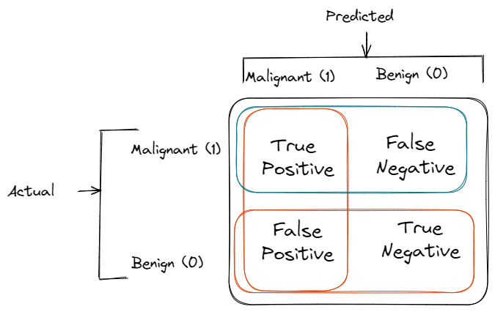
.

Fig.17 Confusion Matrix of Binary Classification
To further enhance evaluation, the classification report from Scikit-learn provides a summarized view of all the metrics precision, recall, F1-score, and support for each class. This report gives a complete breakdown of how the model performs for flood or no flood individually. The inclusion of support helps contextualize the metrics and ensures transparency in how each score is derived. During testing, this report helps researchers and developers assess whether additional tuning or data augmentation is needed to improve the model’s performance across different figurative expressions. The accuracy and loss curves plotted over epochs help identify underfitting or overfitting patterns. For instance, if training accuracy continues to rise while validation accuracy plateaus or decreases, it may indicate that the model is memorizing the training data rather than generalizing effectively. These visualizations, such as the training accuracy plot generated during the experiment, are critical in understanding how well the model adapts to unseen data and whether early stopping techniques are working effectively.

CHAPTER 7: OUTPUT SCREENS

Output Screens

The prediction workflow is executed when the user submits the input form. The Flask backend captures the input data, converts it into the proper format (e.g., a panda DataFrame or NumPy array), and feeds it into the trained flood prediction model loaded via joblib. The model generates a prediction either flood or no-flood which is then passed to the result page template using Jinja2. Conditional logic in the template ensures that the appropriate images and messages are displayed based on the prediction. Running the web application in this way allows real-time interaction with the machine learning model, providing instant flood prediction results to the user, enhancing both usability and practical value. Finally, running the application includes monitoring and debugging for any potential issues. The Flask server can run in debug=True mode during development, which automatically reloads the server when changes are made to the code and provides detailed error messages if any problems occur. Developers can check browser consoles, network requests, and terminal logs to verify that all inputs are correctly processed and outputs are accurately displayed. Once the local testing is successful, the application can be deployed to cloud platforms like Heroku, AWS, or Google Cloud for broader accessibility, enabling real-time flood prediction and decision support for multiple users simultaneously.

The user interface (UI) plays a crucial role in determining the accessibility, usability, and overall effectiveness of the flood prediction web application. A well-designed UI ensures that users can easily navigate through the application, input environmental parameters, and interpret the model predictions without requiring technical expertise. In the context of this flood prediction project, the UI was designed with simplicity, clarity, and visual appeal in mind, catering to both casual users and professionals involved in disaster management. The home page serves as the first point of contact for users. It contains a header with navigation options such as “Home” and “Predict” on the right side and a prominent title or banner like “Floods Prediction System” on the left. This layout ensures intuitive navigation while immediately conveying the purpose of the application. The home page also incorporates a visually appealing background image, which reinforces the theme of weather and environmental monitoring.

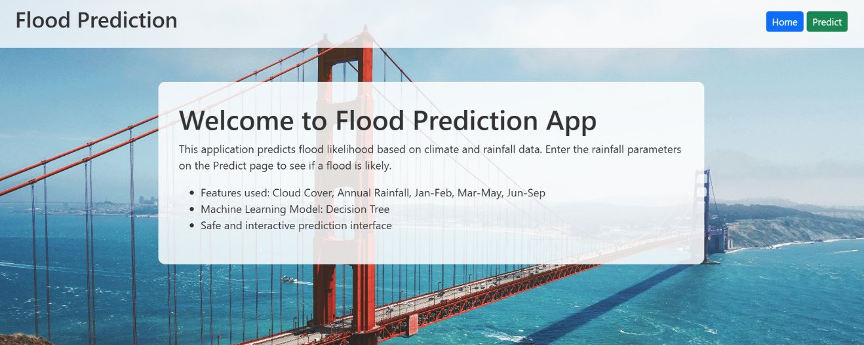
Fig.18 Home page
Information about the flood prediction system is presented in info boxes or content sections on the home page. These sections describe the objectives, methodology, and benefits of the project. For instance, one box may explain how seasonal rainfall data is used to predict floods, while another may highlight the real-world applications, such as early warning for communities and disaster preparedness. This ensures that users understand the context and significance of the system. The predict page is designed to be highly interactive and user-friendly. It includes input fields for the five critical environmental parameters: Cloud Cover, ANNUAL rainfall, Jan-Feb rainfall, Mar-May rainfall, and Jun-Sep rainfall. Each input field is labeled clearly with units and hints to guide the user. The page also includes buttons for submitting the data, such as a “Predict” or “Submit” button. Proper spacing, alignment, and responsive design ensure that the page is visually organized and easy to use on both desktop and mobile devices.
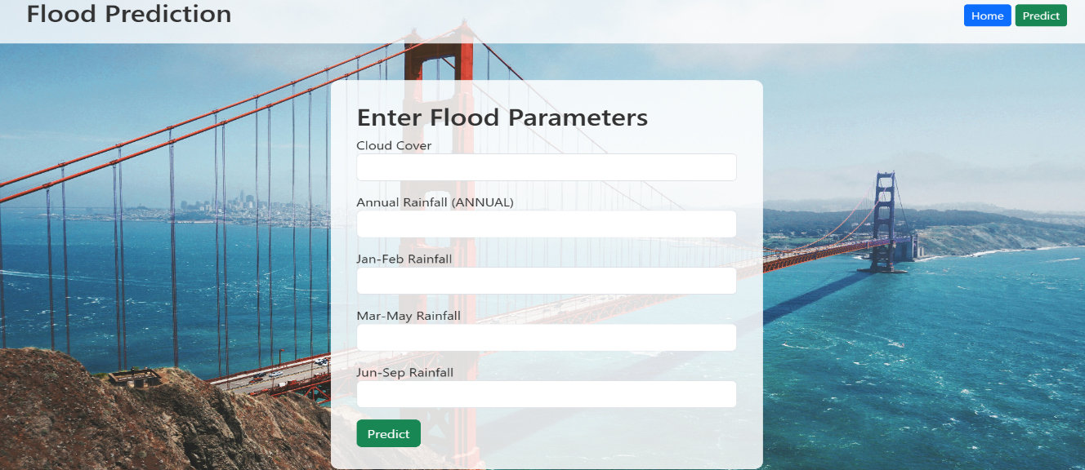
Fig. 19 Prediction Page
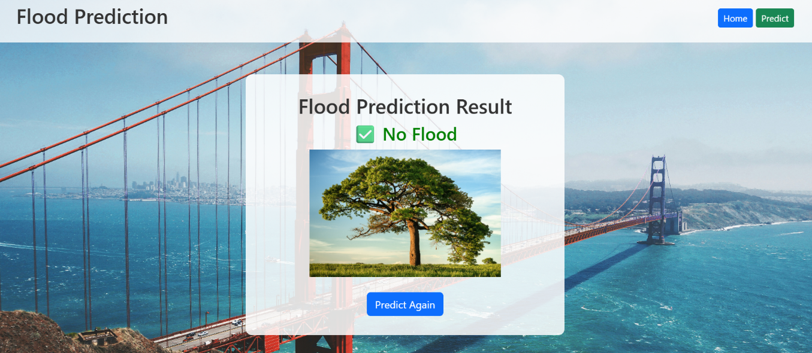
Validation and feedback mechanisms are integrated into the input forms to enhance the user experience. For instance, if a user enters invalid data or leaves a required field empty, the UI can provide immediate visual cues or error messages. This helps prevent incorrect submissions and ensures that the model receives clean, usable data for accurate predictions. Input placeholders, tooltips, and descriptive labels further guide the user through the data entry process. Once the user submits the data, the result page displays the flood prediction generated by the model. This page uses a combination of textual messages and visual cues to communicate the results. For example, if a flood is predicted, an alert image representing floods can be displayed along with a message like “Flood Expected.” Conversely, if no flood is predicted, a calm weather or river image is shown along with a reassuring message. The conditional display of images enhances the user experience by providing immediate visual feedback.

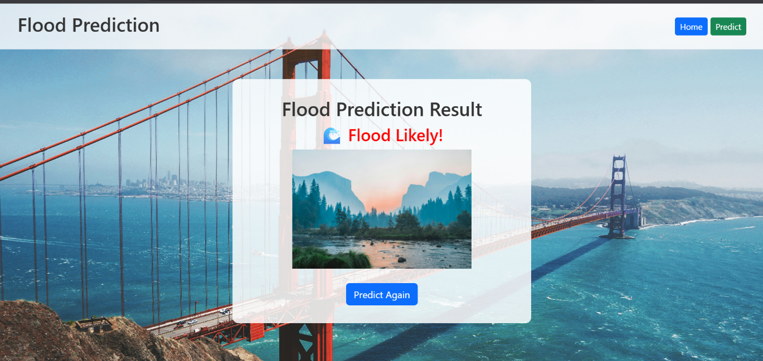
Fig.20 Result Page
The UI is designed with responsive design principles, ensuring that it works seamlessly across different devices and screen sizes. CSS frameworks like Bootstrap or Tailwind CSS can be used to maintain consistent layout, spacing, and alignment. Responsive design ensures that all elements, from input forms to buttons and result sections, adapt gracefully to mobile phones, tablets, and desktops, providing a consistent and professional user experience. Visual aesthetics are an important aspect of the UI. Colors, fonts, and image choices are selected to align with the environmental theme. Soft backgrounds, readable fonts, and contrasting colors for buttons and alerts make the interface both visually appealing and functional. For instance, a red or orange tone may be used for flood warnings to attract attention, while green or blue tones may be used for no-flood predictions to indicate calm conditions.
The UI also incorporates navigation enhancements, such as sticky headers, breadcrumbs, and easily accessible navigation links. These features ensure that users can move between the home page, prediction page, and result page effortlessly. Proper navigation reduces user frustration and helps maintain engagement with the application, which is especially important in high-stress situations like flood monitoring. Interactive elements such as hover effects, button animations, and tooltips improve user engagement. These subtle UI enhancements provide feedback when users interact with buttons or input fields, making the experience more intuitive. For instance, hovering over a “Predict” button may change its color slightly, indicating that it is clickable and active, which reinforces user confidence while using the application.
Integration with dynamic backend functionality ensures that the UI reflects real-time predictions accurately. Using Flask’s Jinja2 templating, the result page dynamically updates based on the model output, showing different images, messages, and even probabilistic scores if desired. This dynamic interaction makes the flood prediction system feel responsive and intelligent, improving user trust in the predictions. The UI also includes informative dashboards or info sections where users can view additional details about the input data, such as the ranges of rainfall values, historical patterns, or feature importance from the model. These sections provide transparency and educational value, helping users understand how the system makes predictions and increasing confidence in the tool. Accessibility is another key consideration in UI design. Text sizes, color contrasts, and button sizes are optimized to ensure that the application is usable by people with visual impairments or other accessibility needs. Ensuring accessibility broadens the potential user base and adheres to best practices in software development.

Error handling and fallback options are embedded in the UI to maintain functionality in case of unexpected issues. For example, if the backend model fails to load or an input value causes an error, the UI can display a friendly message guiding the user to retry or check the input. This ensures robustness and prevents abrupt application crashes that could reduce trust in the system. Performance optimization is also considered in UI design. Images are optimized for web display, scripts are loaded efficiently, and form submissions are handled asynchronously where possible. Fast loading times and smooth interactions are essential for retaining users, especially in emergency scenarios where timely flood information is critical. Finally, the UI is designed to provide a holistic user experience, combining aesthetics, usability, accessibility, and interactivity. From the home page to the prediction and result pages, the interface guides users seamlessly through the flood prediction process. By integrating clear instructions, dynamic feedback, and visually informative elements, the UI ensures that the flood prediction system is not only functional but also engaging and easy to use for all users.

CHAPTER 8: CONCLUSION AND FUTURE ENHANCEMENTS

Conclusion
In conclusion, the development and implementation of our Flood Prediction System using Machine Learning represent a valuable contribution toward minimizing the impact of flood-related disasters. By utilizing climatic and rainfall-based input parameters, the system efficiently predicts the likelihood of flood occurrence. We trained and evaluated multiple machine learning models, including Decision Tree, Random Forest, K-Nearest Neighbors (KNN), and XG Boost, to determine the most effective model for accurate prediction. The comparative analysis of these models demonstrated that the Random Forest and Decision Tree models achieved superior classification performance, consistently delivering high accuracy, precision, recall, and F1-score, as shown in the evaluation results. Through proper data preprocessing, feature scaling, and hyperparameter optimization, the flood prediction system ensures reliable and consistent performance in real-world scenarios. This system can assist government agencies, disaster management authorities, and local communities by providing timely alerts and supporting preventive planning. The overall design emphasizes scalability, simplicity, and real-time usability, thus enabling proactive flood risk mitigation and safeguarding lives and property.
.

Future Work
- Real-Time Flood Monitoring:
Implement real-time data streaming from weather stations, satellite rainfall data, and IoT-based river level sensors to generate continuous and dynamic flood predictions.
- GIS and Map-Based Visualization:
Integrate Geographic Information System (GIS) mapping to display high-risk flood zones visually, enabling better decision-making and situational awareness.
- Deep Learning Model Integration:
Incorporate advanced deep learning models such as LSTM for time-series rainfall prediction to further enhance forecasting accuracy.
- Mobile Application Deployment:
Develop a mobile app for instant flood alerts and guidance for local citizens, farmers, and disaster response teams.

APPENDIX

User Manual

Download VS code
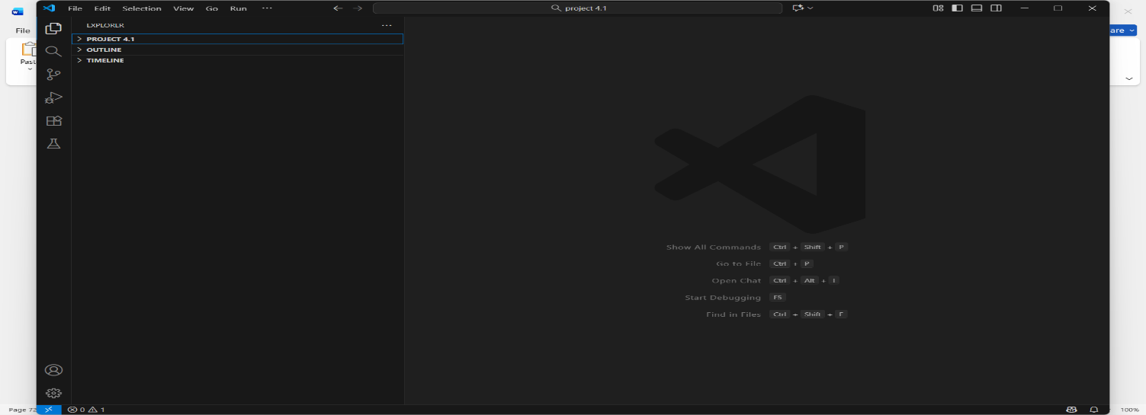

Figure A.1: VS Code Download

Create New Environment
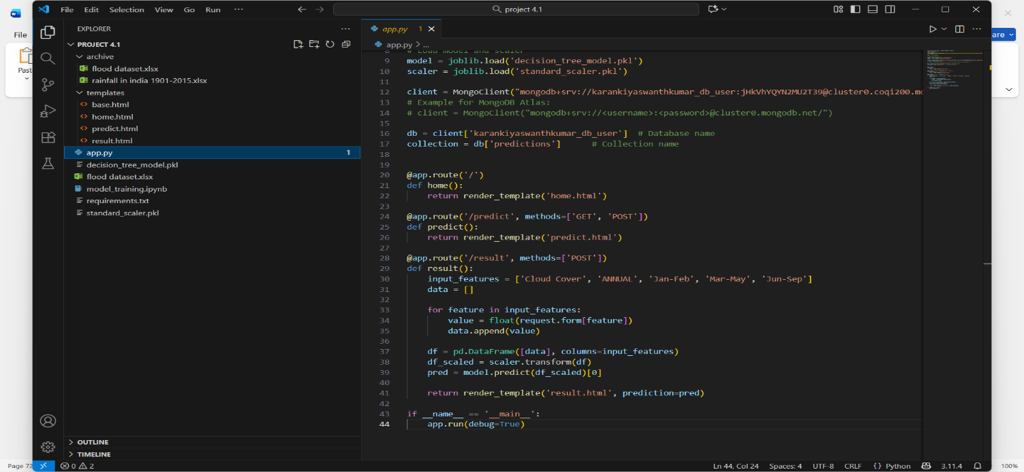

Figure A.2: Creating New Environment

Click on Open Terminals and Execute the Commands
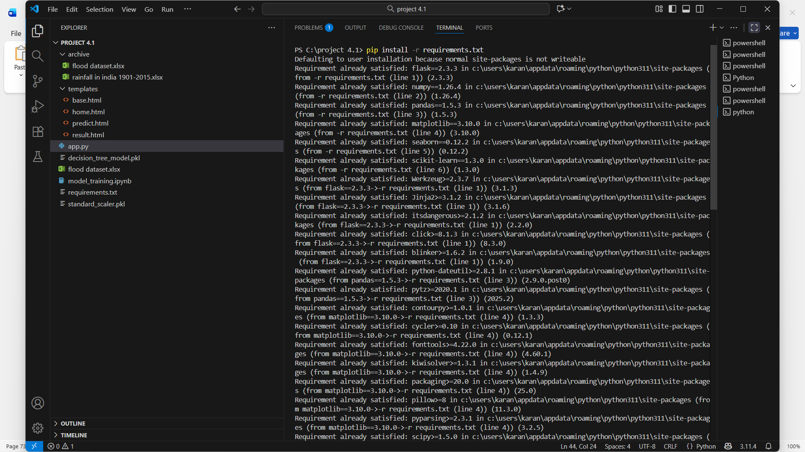

Figure A.3: Commands Execution

Run the Application
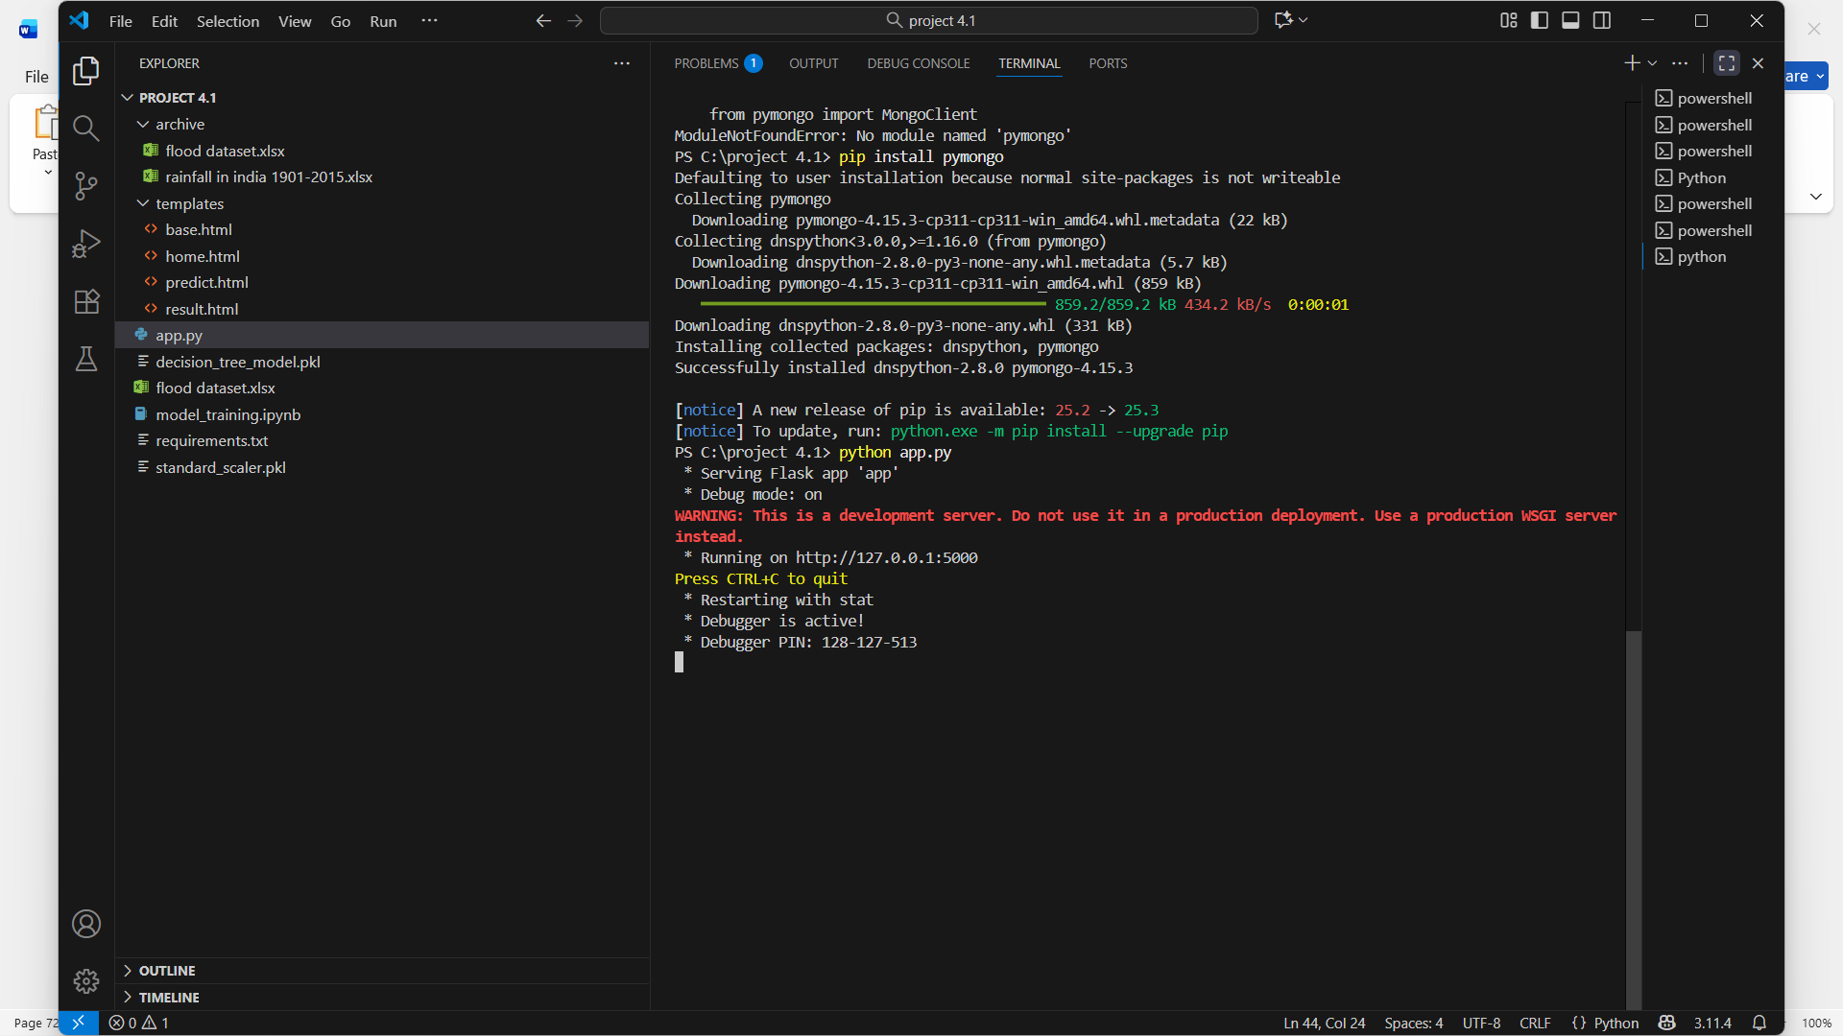

Figure A.4: Run the Application

REFERENCES
Several research studies have contributed to the advancement of flood prediction using machine learning and intelligent data-driven systems. Patel and Shah (2024) proposed a flood prediction model using machine learning techniques that focused on analyzing historical climatic data, including rainfall intensity, humidity, temperature, and soil absorption levels [1]. Their study demonstrated that machine learning models could effectively recognize hydrological patterns that traditional models often fail to detect. The research highlighted that Decision Tree and Random Forest classifiers performed well in classification accuracy, showing that machine learning can significantly improve early warning flood systems. This work forms the foundational understanding of how environmental parameters can be translated into predictive insights for flood monitoring.
Smith and Kumar (2024) extended this approach by utilizing Neural Network-based architectures for hydrological flood forecasting [2]. Their study emphasized the ability of deep learning, specifically artificial neural networks (ANN), to capture non-linear and complex relationships between multiple hydrological variables. They experimented with rainfall-runoff datasets and showed that neural networks provided more stable and reliable predictions than conventional models when dealing with fluctuating environmental conditions. Their research is particularly relevant because it demonstrates how deep learning models enhance predictive accuracy, which directly supports the decision to use neural networks in flood detection systems.
Furthermore, Singh and Zhao (2023) introduced a real-time flood prediction model using IoT sensors combined with machine learning algorithms [3]. Their system collected real-time environmental data such as river water levels, rainfall measurements, and humidity through IoT-based monitoring stations. This data was then processed using ML models to generate early warning alerts. The key contribution of their work lies in integrating hardware monitoring with intelligent software prediction models, enabling real-time decision-making and disaster response. This aligns with the direction of modern flood warning systems, which require automation, rapid updates, and remote monitoring.
Together, these studies provide a comprehensive research foundation for flood prediction using machine learning. Patel and Shah demonstrated the feasibility of machine learning for historical flood classification, Smith and Kumar highlighted the advantages of neural networks for complex environmental prediction, and Singh and Zhao showcased the integration of real-time sensing with intelligent prediction. These research contributions collectively support the design and methodology of the proposed flood prediction system, ensuring improved accuracy, real-time decision making, and enhanced public safety response mechanisms.

